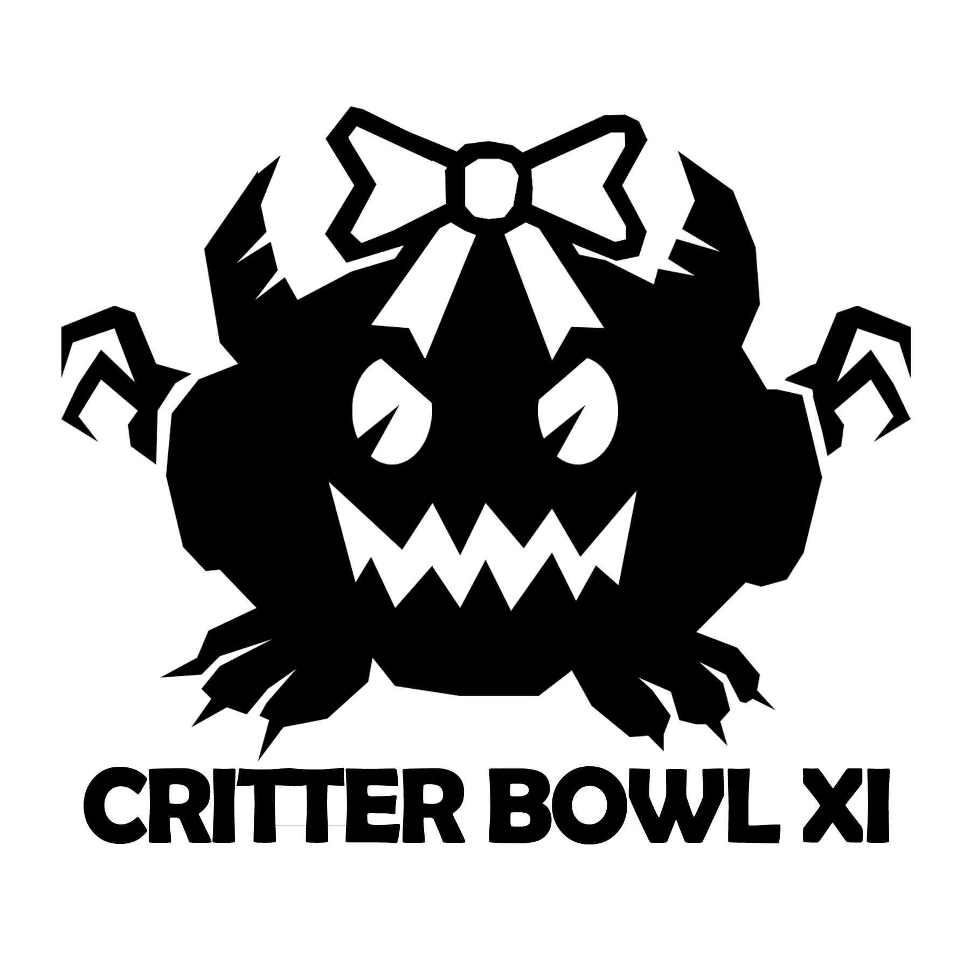
TOURNAMENT RULES PACK 2024
Dec 7th, 2024 at Wizards Asylum
3719 W. Main Street
Norman, OK 73072

Welcome to Critter Bowl! Why Critter Bowl?

This event started in 2013 as a Baby Shower/Blood Bowl Tournament for our buddy Sarge (Mike Tate). At the time of the event he and his wife currently were undecided on the baby’s name so until they came up with something they called the baby “Critter”. Thus the event became Critter Bowl. This is a baby shower disguised as a Blood Bowl Tournament.

This year we continue the Baby Shower/Blood Bowl Tournament tradition for the Davies Family.

If there is anyone out there that cannot make it and you still want to pitch in for the Baby Shower side of this event please let us know.

PLEASE NOTE: All entry Fees for this tournament will go towards a gift card for the family to spend on the new family. In addition we will have some stuff for raffle at the event as well, with all proceeds going to the Whitebird family.

Cost and Sign up!
In order to Register for this tournament you must do the following:
- Entry- Send $25 (or more) via Paypal to fatfinley@hotmail.com, On-site Sign-ups will be $30 please pay as "Friends and Family" so I don't get charged or taxed for this event.
- Rosters- All coaches that pre-register for Critter Bowl 10 are required to send in their Roster by Nov. 30, 2024.
Players can email their Roster to BDRosters@gmail.com
- Rosters turned in on time will get that coach 5 bonus points plus the 1st Tiebreaker in standings
- Rounds- This is currently scheduled for 4 round event. If this event gets less than 16 players we will run a 3 round tournament instead of 4 rounds.

Tournament Schedule
8:00 – Check-In Starts
8:30 – Check-In Ends, going over the Special Ball rules begin!
8:45 – Round 1 (Random)
11:00 – Break
11:15 – Round 2 (Swiss)
1:30 – 2:15 – Lunch
2:15 – Round 3 (Swiss)
4:30 – Break
4:45 – Round 4 (Swiss, Bowl Round) (if needed)
7:00 – Break
7:30 – Results/Awards

What you should bring
- Your Painted Blood Bowl Team
- Five Copies (one for each round) of team roster
- Blood Bowl Field/Dugouts/Templates
- GW or NAF Block Dice & D8
- Printed Copy of Competition Rules (CRP)/LRB6 can be found here- http://www.games-workshop.com/MEDIA_CustomProductCatalog/m780049a_Blood_Bowl_Competition_Rules.pdf
- Plus the three new teams list http://www.orclahomabowl.com/documents/New_Teams.pdf

Things we will provide
- Pen
- Dice and 1 Raffle Ticket
- Awards

Rules
NAF Rules for Tournaments
NAF 2021 Download
Grandma Wendy's FAQ

- Blood Bowl Second Season (2020) Rule Set
- All Races in the Rulebook, Teams of Legend Document, & NAF additional
- Special Play Cards will not be used
- All injuries reset after each game
- Apothecaries work as described in the Rulebook
- Illegal Procedure can be shouted but will not be penalized
Team Building Rules

You are given 1,150,000 gold pieces to build your team. You may purchase players, rerolls, fan factor, coaches, and cheerleaders as normal with this money. Wizards, Journeymen, Special Play cards of any kind, Mercenaries, Giants, and the Halfling Hot Pot are NOT ALLOWED.

You may purchase any other inducements for your team, including Star Players (Cost 3 SPP). No Mega Stars are allowed.

Note: If you are including a Star Player, you must have 11 players on your team BEFORE hiring them. Having 10 players plus a Star is not allowed. Remember: You can not have the same Star Player as your opponent. If both of you attempt to field the same player, then that star player has swindled you both!! Neither of you can field them. Also, you cannot use Igors or Apothecaries on Star Players.

**All new star players from the Second Season Edition and subsequent Spike Journals will be allowed. Second Season Edition has given Star Players each their own "Special Rule". If you have a Star Player on your roster, you are expected to explain the "Special Rule" to your opponent.**
For this Event we will use the tiering system below.
Tier 1 teams get 7 SPP to spend:
Amazon, Dark Elf, Chaos Dwarf, Dwarf, High Elf*, Lizardmen, Necromantic Horror, Norse, Orcs, Shambling Undead, Skaven, Underworld Denizens, Wood Elf

Tier 2 teams get 9 SPP to spend:
Black Orc, Chaos Chosen, Chaos Renegade, Elven Union, Human, Imperial Nobility, Khorne, Nurgle, Old World Alliance, Slann*, Snotlings, Tomb Kings*, Vampire

Tier 3 teams get 11 SPP to spend:
Gnomes. Goblin, Halfling, Ogre

* Teams of Legends (plus Slann) are marked above as they cannot win any tournament awards except for the "I am Legend" Award (See Awards below)

- Primary Skills are 1 SPP
- Secondary Skills are 2 SPP.
- No Stat increases.
- Maximum four (4) of any skill.
- You may put a second Primary skill on a player, but it counts as double the cost of a Primary Skill (2 SPP). Example a player with two primary skills cost 3 total SPP for those two primary skills.
- You may NOT put a Secondary Skill and Primary on one player.
- You may not add skills to Star Players
- Star Players cost 3 SPP of your allowed SPP.
- No Mega Star Players are allowed!

Special Balls
Round 1-3 every game will be played with Special Balls (See last page of this document). In Tournament Rounds 1 thru 3 the kicking team will roll a D10 for the ball being used that drive. After each drive ends a new ball is randomized.

Round 4 All teams will be at their own Bowl game where the ball will not be randomized but will specific to the bowl, in addition each kickoff both teams get a roll on the "Prayers to Nuffle" table. Example your team might be playing in the Nurgle King Bowl which only uses the Nurgling ball. You might not win any awards but if you win your last game you will be a Bowl Winner, and that is something to brag about!

Weather
Everyone will roll for their own weather.

NAF Tournament Info
This is a NAF approved tournament. If you wish to receive limited edition gift and have your tournament progress tracked, there will be an NAF registration onsite for the cost of $5/year.
More information can be found at TheNAF.net

Illegal Procedure
In the spirit of good sportsmanship, Illegal Procedures will not be called

Timing
The two hour rounds WILL be strictly enforced. You will receive ‘Time Remaining’ updates from the Tournament Organizer to help you stay on pace.

The 4 Minute turn rule will not be used unless the Tournament organizer feels your game is in danger of not completing in the two hour timelimit. He may insist on a timer being used and enforcing the 4 minute turn rule.

Dice
Only GW or NAF Block Dice may be used and only the Critter Bowl D6’s received at registration may be used. You and your opponent should decide whose set of dice will be used.

Scoring
After each round you will fill out the game sheet based on the game just completed.
- A WIN is worth 3pts
- A DRAW is worth 1pts
- A LOSS is worth 0pts

Overtime
There will be no overtime played. If your game ends in a draw, it’s a draw.

Tiebreakers
The Scoring system has been setup to hopefully get the most accurate representation of how everyone has performed. If, by chance there is a tie in Tournament points, the ties will be broken in this order:
- Roster turned in on time
- Bonus Points
- Winning Percentage
- Strength of Schedule
- Head to Head record
- Net TDs plus Net CAS
- Total TDs plus Total CAS

If it is still a tie at that point, the tournament organizer will use his best judgment in finding a way to break the tie.

Painting
All teams are expected to meet the minimum painted guidelines. They must have 3 colors on them and have had some attempt at making them appear finished.

Sportsmanship
We are here for the fun of the game. Sportsmanship is not encouraged from the coaches it is required!

Fouling 16 turns in a row and running up the score is not poor sportsmanship, but gloating and ridiculing your opponent while doing so is.

Sportsmanship Awards will be determined based on answers given in the Etiquette Sheet.

Tournament Organizer will strictly enforce the “Don’t be a Douche” policy. Basically, it consists of not performing any acts of Douchebaggery.

Awards
The following awards will be given out after the last round.
(Note: Teams of Legends and Slann can only win the "I am Legend Award")
  - Grand Champion - Winner highest ranked team in the standings
  - Blood Hill Cup - Second Place in team standings
  - Del Zine Cup - Third in team standings
  - Best Offense - Team that scored the most TDs
  - Best Defense - Team that allowed the fewest TDs
  - Most Brutal - Team that inflicted the most Casualties from Blocking
  - Stunty Cup – Highest rated Stunty Team (Halflings, Gnomes, Goblins, Ogre, Snotlings) in standings
  - Fan Favorite - Best team as decided by player vote. Tournament Organizer will have final say and break any ties.
  - Best Sportsman - Best Sportsman as decided by player vote. Tournament Organizer will have final say and break any ties.
  - Poopy Diaper Award - Coach that finished with lowest number of Tournament points
  - "I am Legend" Award- This award can only go the highest rank Chaos Dwarf, High Elf,

Spread The Wealth
A coach may only win one award. If they are in line to win more than one award, they will be asked which one they would prefer and the next coach in line will be given the other award.

QUESTIONS? Email us at bdrosters@gmail.com for Answers!

Critter Bowl
Special Ball Table

1 | Scarab Ball – The ball is replaced by a Scarab. Any time the ball lands in an empty square. It will move in a random direction decided by the scatter template (D8) and will move a D6 worth of squares. It will move its full movement before a bouncing ball pick-up attempt can be used. The ball will never move out of bounds on its own. It could be kicked out of bounds on a kick off.
2 | Honey Badger Ball – This ball is super sticky. Anytime someone tries to hand off or pass the ball they must roll a D6, on a results of a 1 or 2 the Ball is stuck to the player and the action for that player is over. This player also gets the Sure Hands and Safe Pair of Hands skill.
3 | Baby Orcipine Ball – Any failed pick up or catch roll (but not interception roll) is treated as the player being attacked with the Stab skill by an opponent.
4 | Baby Griffin Ball – A baby Griffin can soar thru the air with ease. The players passing the ball gets the following, +0 to all Quick Pass attempts, +1 on Short Pass attempts, +2 to all Long Pass or Long Bomb attempts.
5 | Dead Pig Ball – It’s a dead pig used as the ball… nothing special here, except we can eat him after or during the game.
6 | Baby Troll Ball – Yes they will be playing the game with a baby Troll as the ball. The Baby Troll Ball gives the holder Projectile Vomit, Really Stupid and Loner (4+).
7 | Ginger Badger Ball – This little critter gets angry and hot when held. When a player with this ball begins an action he must roll a 2D6, on any doubles rolled, the player gains the Fumblerooskie skill and must use it, on a 2-6 the player withstands the heat for the turn.
8 | Morg Plush Doll Ball – It’s a stuffed doll of the greatest Ogre Blocker ever, Morg N’thorg… the plushie seems to give the player holding the ball delusions of grandeur as the player holding this ball has the following skills, Bone-Head and Mighty Blow (+1).
9 | Dragon Egg Ball – When this ball hits the ground it emits a fireball. The location of the ball is always the center of the fireball, to see who is hit by the fireball use the Fireball rules found with the Wizard Rules (Rulebook).
10 | Davies Ball – This baby ball is full of magic... This ball gives the holder Very Cute (works like Foul Appearance) and Stunty (if tackled Stunty leaves the player after the armor roll and injury roll occurs), Horns

