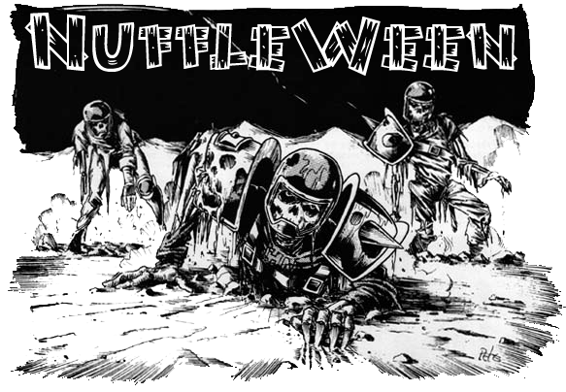
TOURNAMENT RULES PACK 1.0
2522

Nuffleween: The Final Chapter!

November 12th, 2022 at Wizards Asylum
3717 W Main St. Norman, OK 73072

Cost
$30 at the door
$25If you Pre-register by November 1st 2022 at website.

Things we will provide
Pen
Nametag
Match Sheet
Custom Dice
Awards

Tournament Schedule
8:00 – Registration Starts
8:15– Registration Ends
8:30– Round 1 (Random)
10:45 – Break
11:00 – Round 2 (Swiss)
1:15 – Lunch
2:15– Round 3 (Swiss)
2:30– Break
4:45– Round 4 (Swiss/Finals)
7:00– Break
7:15– Results/Awards

What you should bring
- Your Painted Blood Bowl Team
- 5 copies of your roster (Click here for Blank Roster template)
- Blood Bowl Field/Dugouts/Templates
- Block Dice, D8 and Ball. The Both Down Kick-Off D2/D3 die is recommended.

Rules
NAF Rules for Tournaments
NAF 2021 Download
Grandma Wendy's FAQ
- Blood Bowl Second Season (2020) Rule Set
- All Races in the Rulebook, Teams of Legend Document, & NAF additional
- Special Play Cards will not be used
- All injuries reset after each game
- Apothecaries work as described in the Rulebook
- Illegal Procedure can be shouted but will not be penalized

NuffleWeen Tournament Special Rules and Team Building

Nuffleween Kick Off Table
The old stars are back trying to shine again…
All tables will use the enclosed Kick Off Table

Team Building Rules
You are given 1,100,000 gold pieces to build your team using Official GW or Team of Legends teams. Slann is available per NAF rules. You may purchase players, rerolls, apothecary, fan factor, coaches, and cheerleaders as normal,
All inducements are allowed as regular besides wizards, Should you take an inducement that is specific for your team, please make sure your opponent is aware of its abilities before the start of your game.
You will be able to get skills later, see Additional Skills next page.

Star Players
Due to alleged undue influence by the Honorable and Agreeable Guild of Stars (HAGS), Nuffleween Organizers have decided to not allow any stars except those mentioned below..

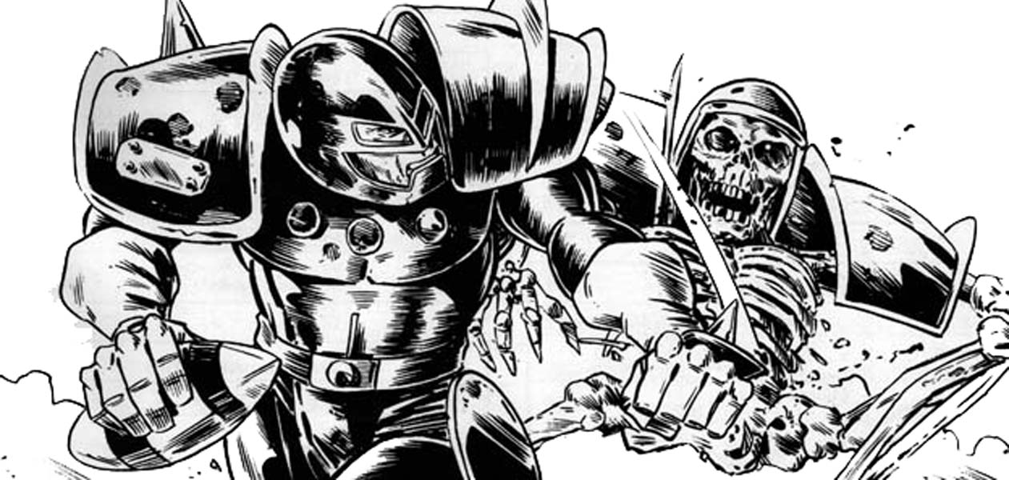

NuffleweenSpecial Star Players Rules
Any Nuffleween Star Player will count towards your 11 players needed for initial team creation. They still count as one of your 2 Star Players allowed on a team.
Note: You can purchase any of the Dead/Undead superstar’s listed below.
The following players can be used on ANY team.
- Bryce Cambuel
- Frank N. Stein
- Gretchen Wachter
- Skrull Halfheight
- Wilhelm Cheney

Rule for Multiple of the Same Star Player
This is a once in a lifetime event for most of the guys. As such, some players may pretend to be a Star Player or some of the smart ones will be cloned by Wizards to get double the pay. What does that that mean? Star Players may play for both teams as there is no “Highlander Rule”.

All Star Players follow the same rules that handbook. 0-2 Star Players may be purchased per team.
Apothecaries cannot be used on Star Players

Additional Skills
After you build your team with the 1,100,000 gold pieces your team gets an additional 48 SPPs that you can choose to spend however you would want on skills for your team.

A Primary skill upgrade costs 6 SPPs
A Secondary skill upgrade costs 12 SPPs

You may only assign one additional skill per player, and no skill may be taken more than three times. You may not assign a skill to a Star Player.

All Injuries will reset as this is a Resurrection Tournament

“Trick” or “Treat” Tournament Rule

Before each round, Nuffle will give you either a “Trick” or a “Treat”. The 1st Round will be played as if Nuffle has given everyone a “Trick”. All skills lost during the Treat or Trick phase of the game are gone for the rest of the tournament, so choose wisely.

“Trick” – If you won or tied your last game, Nuffle will select a player at random that received a purchased skill and that player will lose that skill for the rest for the Tournament.

“Treat” – If you lost your last game, Nuffle will let you pick a player that received a purchased skill and that player will lose that skill for the rest for the Tournament.

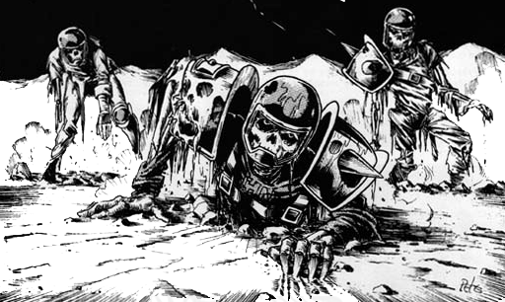

NAF Tournament Info
This is a NAF approved tournament. If you wish to receive limited edition yearly gift and have your tournament progress tracked, there will be an NAF official onsite accepting registration for the cost of $5/year. More information can be found at TheNAF.net

Timing
The time limit WILL be strictly enforced. You will receive ‘Time Remaining’ updates from the Tournament Organizer to help you stay on pace.
When time is called, you will play to “even turns”. If you just started turn 7(for example), then you and your opponent each finish turn 7. If the active player is the last part of a turn, the game ends upon completion.
Intentionally stalling is not allowed by the coach (stalling with the team is fine), each turn should take roughly 4 minutes. If the organizer feels that someone is stalling, a 4 minute timer may be used.

Dice
You are required to share dice with your opponent if requested. Only the Nuffleween Tournament D6’s received at registration may be used. You and your opponent should decide whose set of dice will be used.

Scoring
During each round, you will fill out a score sheet to track your progress. At the end of the match, you will add up the scoring as follows:
- A WIN is worth 60pts
- A DRAW is worth 30pts
- A LOSS is worth 10pts
- If you lost by 1 Touchdown, you earn +2 bonus pts
- If you caused 1 more CAS from Blocking than opp you earn +2 bonus pts
- If you caused 2 or more CAS from Blocking than opp you earn +5 bonus pts
- If you clear the pitch you earn +5 bonus pts (Once per game)
- If you won by 2 Touchdowns you earn +2 bonus pts
- If you won by 3 or more Touchdowns you earn +5 bonus pts
- If you finished the game by using all turns +3 bonus pts

There is a no championship game the standings will solely be determined by total points

Overtime
There will be no overtime played. If your game ends in a draw, it’s draw.

Tiebreakers
The scoring system has been setup to hopefully get the most accurate representation of how everyone has performed. If, by chance there is a tie in Tournament points, the ties will be broken in this order:
- Winning Percentage
- Strength of Schedule for this tournament as determined by SCORE program
- Head to Head record for today (if applicable)
- Net TDs plus Net CAS
- Total TDs plus Total CAS
- Thriller Dance Off

If it is still a tie at that point, the tournament organizer will use his best judgment in finding a way to break the tie.

Painting
All teams are expected to meet the minimum painted guidelines. They must have 3 colors on them and have had some attempt at making them appear finished.

Sportsmanship
We are here for the fun of the game. Sportsmanship is not encouraged from the coaches it is required!
Fouling 16 turns in a row and running up the score is not poor sportsmanship, but gloating and ridiculing your opponent while doing so is.
Tournament Organizer will strictly enforce the “Don’t be a Douche” policy. Basically, it consists of not performing any acts of Douchebaggery.

Awards
In order to qualify for any award, the coach must complete all 4 rounds.
The following awards will be given out after the last round:
  - Nuffleween Champion - Team that has the most points after 4 rounds
  - 2nd Place -Team that has the 2nd most points after 4 rounds
  - Del Zine Cup (3rd Place) - Team that has the 3rd most points after 4 rounds
  - Best Offense - Team that scored the most TDs that did not place 1st - 3rd
  - Best Defense - Team that allowed the fewest TDs that did not place 1st - 3rd
  - Most Brutal - Team that inflicted the most Casualties from Blocking that did not place 1st - 3rd
  - Fan Favorite - Best fan favorite team as decided by the participants of the event. It could be based on anything, models, paint job, theme, your vote for the best team at the event.Tournament Organizer will break ties.
  - Best Sportsman - Best Sportsman as decided by participants. Tournament Organizer will break ties.
  - Stunty Cup - Stunty team with the most tournament points.
  - Back of the Pack - Coach that finished with lowest number of Tournament points.

Spread The Wealth
A coach may only win one award. If they are in line to win more than one award, they will be asked which one they would prefer and the next coach in line will be given the other award. Tournament organizers reserve the right to adjust the awards, i.e.Back of the Pack has to have played in all 4 rounds.

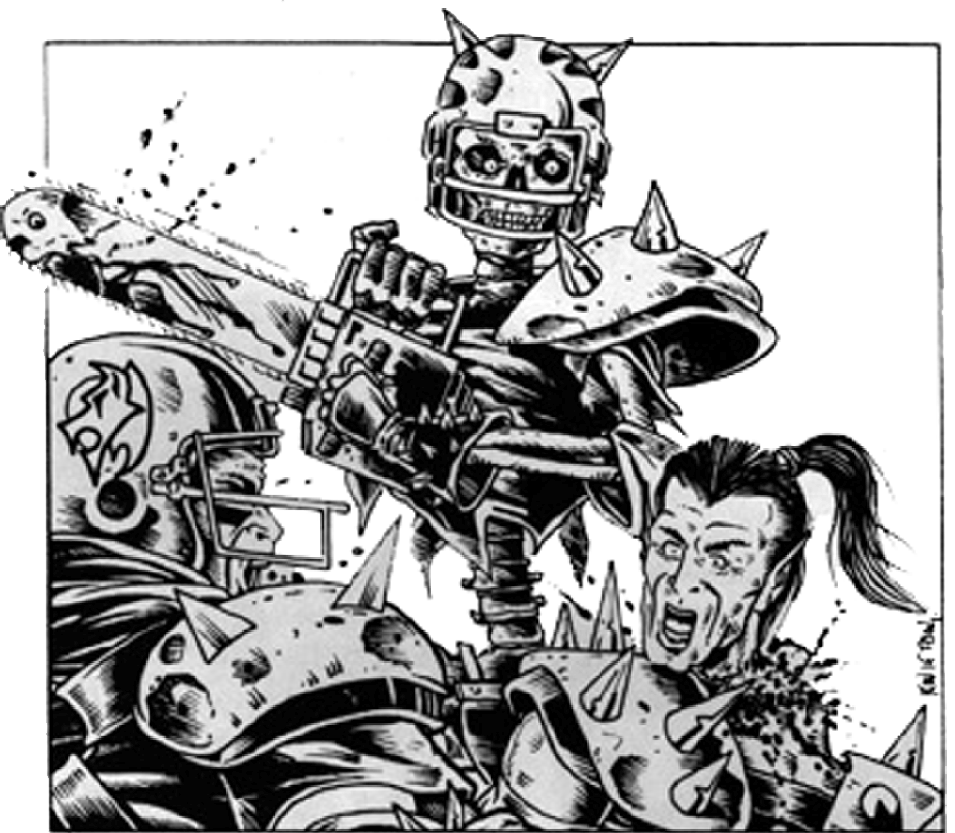

QUESTIONS? Email us at bothdownpodcast@gmail.com for Answers!
NUFFLEWEEN
KICK-OFF TABLE
2 | “You son of a bitch! I'll give ya something to remember us by!” – Out from the shadows, the grim visage of Count Luther Von Drakenborg shows up and entrances all the refs. No fouls will be called this drive.
3 | “Two of 'em. Two. Count 'em. One, two.” – The twin terrors (nobody ever called them this) of Humerus Carpel and J Earlice have shown up and decided to throw a party. What’s a party without some punch? Each coach chooses one of their players to try the punch. For each player, roll a D3. One a 1, nothing happens. On a 2, the player is stunned. On a 3, the player can rush 2 additional spaces but with a success of 5 or 6.
4 | “Read my lips, leave me alone! AAH!” – Simply trying to enjoy the game until he was bothered by too many fans, Rotten Rick Bupkeis decides he’s had enough. A spectator is thrown onto the pitch. This is a human spectator with MA 6. He starts in the kicking team’s end zone (kicking coach chooses where) and is running towards the other end zone. The active player moves the spectator at least 3 spaces towards the other end zone each turn. The spectator is not able to be hit, can not interact with players or the ball. When he reaches the other side, he’s gone.
5 | “I'll tell you where I'm going! I'm going crazy!” – It’s the return of Crazy Igor! Crazy Igor loves to get crazy. Every player gets stab. That’s it. Enjoy. Every player on the pitch this drive gets stab. Lose it at end of drive.
6 | “Hey, honey, you got a sister? Ruff, ruff!” – For some reason, famed Star Player Sinnedbad (nobody ever called him that) has decided to harass the cheerleaders. Each player rolls a D6 and adds Cheerleaders. Lowest roll means Sinnedbad has distracted your sidelines enough to make you lose a reroll. No effect if tied.
7 | “Die! Die! Die! Die!” – Hearing the cries from the fans, Ramtut III rises from the center of the pitch. As he walks to the sidelines you see a vast sea of hands reaching up from the ground. Add +2 to all armor rolls unless the player has the stunty skill, then you add +1. This ends at the end of the drive..
8 | “Hey, congratulations, Jimbo” – “It’s impalin’ time!” you hear from the sidelines. Throttlesnot the Impaler sprints out and goes after the players. The players see a pogo stick riding, knife wielding maniac charging towards them. Each player rolls a D16. On a 1-15 nothing happens and he’s laughed off the pitch, on a 16 he gets pissed and kills a random player on your team. Straight up stabbed in the face death. Good job.
9 | “Hey. That's you they're talking about on TV, pal” – Olde World Famous G’Ral Blodschuker (He’s never been called this, who’s writing this?) shows up on the jumbotron and leads the crowd in a chant. Unknown to them, the chant opens a couple portals to hell. Any player pushed into a trap door area is banished to the infernal chasm and out for the rest of the game.
10 | “Someone left the front door open again” –. Someone let Ivan “The Animal” Deathrshroud out of his cage. He’s shown up and is just being a pain. You know those rerolls you enjoy using? He doesn’t like the Probability Wizards and is chasing them around. Roll a D6 each time any coach attempts to use a reroll, on a 1 it is wasted.
11 | “It says you're a dead f---" – Not wanting to miss out on the fun, Hack Enslash has shown up with chainsaw in hand. One random player from each team gets a chainsaw to the face. Roll armor +3 and roll for injury as normal. No roll is needed to make sure the chainsaw works, he’s been keeping it in good working order.
12 | The Final Chapter – It’s over… for someone. Roll a D6 for each player on the pitch. Any player that got a 6 (or the highest roll if no 6s were rolled) rolls again. Repeat process until only 1 player remains as the chosen one.  Roll a D16. On a 1-14, they’re placed in the reserves. On a 15 or 16, that player is dead for the remainder of the game. When they come back next game, they get +1 ST. If this is the last game of the day, they come back next drive with a +1 ST.

