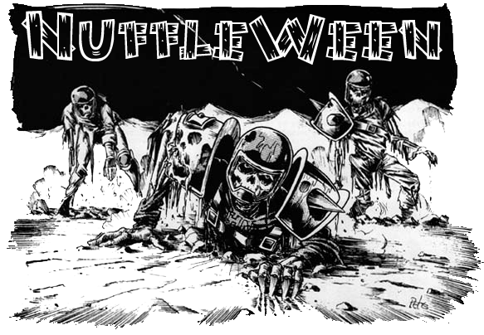
TOURNAMENT RULES PACK 1.0
2519

NuffleweenVIII:
Frank N. Fest 2519!

November 9th, 2019 at Wizards Asylum
3717 W Main St. Norman, OK 73072

Cost
$30 at the door
$25If you Pre-register by November 1st 2019 at website.

Things we will provide
Pen
Nametag
Match Sheet
Custom Dice
Awards

Pre-Registration Bonus
If you pre-register by November 1st will also get 2 additionalNuffleween D6’s, plus $5 off.

Tournament Schedule
8:00 – Registration Starts
8:15– Registration Ends
8:30– Round 1 (Random)
10:45 – Break
11:00 – Round 2 (Swiss)
1:15 – Lunch
2:15– Round 3 (Swiss)
2:30– Break
4:45– Round 4 (Swiss/Finals)
7:00– Break
7:15– Results/Awards

What you should bring
- Your Painted Blood Bowl Team
- 5 copies of your roster (Click here for Blank Roster template)
- Blood Bowl Field/Dugouts/Templates
- Block Dice, D8 and Ball. The Both Down Kick-Off D2/D3 die is recommended.

Tournament Rules
- Per the NAF, the CRP version of Piling On will be used
- Roster changes in BB16, All Spikes, DZ1 and DZ2 are being used (ie – Humans, Orcs, Gobbos, etc)
- Any Star Players in the CRP, BB16, DZ1 or DZ2 are allowable. Grak and Crumbleberry are allowed using most recent rules
- Any optional rules (Refs, White Dwarf/Black Goblin, etc) will not be allowed
- Arguing the call - In order to be allowed to make use of this, you are required to have a fully painted head coach model that is thematically consistent with your team, is not a standard player model and has some indication of being a coach(hat, playbook, whip, etc). The determination of acceptable models is by the tournament organizer.

NuffleWeen Tournament Special Rules and Team Building

Special Weather Table (None) Players will use the normal weather for each game.

Nuffleween Special Stadiums
All match-ups will be played on Nuffleween random pitches. Each pitch will have its own special rules that will be used for that one game. See "Stadiums" at the end of this document.

Team Building Rules
You are given 1,100,000 gold pieces to build your team using CRP team lists or the three additional Team Lists. You may purchase players, rerolls, apothecary, fan factor, coaches, and cheerleaders as normal. You will be able to purchase skillslater, see Additional Skills next page.

The only inducements allowed for purchase are Bribes, Halfling Chef, Star Players and Horatio X. Schottenheim from Death Zone 2.

CRP Star Players
Note: If you are including a regular Star Player from the CRP Rule Book, you must still have 11 players on your team BEFORE being able to hire them. Having 10 players plus a Star Player is NOT allowed. Unless that player is a Nuffleween Star Player.

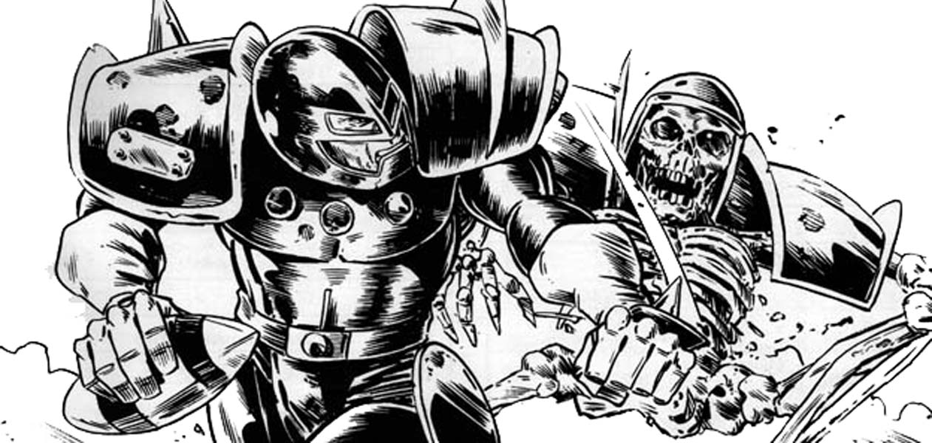

NuffleweenSpecial Star Players Rules
Any Nuffleween Star Player will count towards your 11 players needed for initial team creation. They still count as one of your 2 Star Players allowed on a team.
Note: You can purchase any of the Dead/Undead superstar’s listed in CRP Rules pack. The following players can be used on ANY team.
- Bryce Cambuel
- Count Luthor Von Drakenborg
- Frank N. Stein
- Gretchen Wachter
- G'Ral Blodschuker
- Ivan Deathshroud
- Ramtut III
- Rotten Rick Bupkeis
- Skrull Halfheight
- Throttlesnot the Impaler

Each of these players will have Fan Favorite skill for free. The Fan Favorite will not stack for this tournament.

Rule for Multiple of the Same Star Player
This is a once in a lifetime event for most of the guys. As such, some players may pretend to be a Star Player or some of the smart ones will be cloned by Wizards to get double the pay. What does that that mean? Star Players may play for both teams as there is no “Highlander Rule”.

All Star Players follow the same rules that are in the CRP Rule Book. 0-2 Star Players may be purchased per team.Apothecaries cannot be used on Star Players

Additional Skills
After you build your team with the 1,100,000 gold pieces your team gets an additional 150K that you can choose to spend however you would want on skills for your team.

A normal skill upgrade costs 20,000
A doubles skill upgrade costs 30,000

You may only assign one additional skill per player, and no skill may be taken more than three times. You may not assign a skill to a Star Player.

All Injuries will reset as this is a Resurrection Tournament

“Trick” or “Treat” Tournament Rule

Before each round, Nuffle will give you either a “Trick” or a “Treat”. The 1st Round will be played as if Nuffle has given everyone a “Trick”. All skills lost during the Treat or Trick phase of the game are gone for the rest of the tournament, so choose wisely.

“Trick” – If you won or tied your last game, Nuffle will select a player at random that received a purchased skill and that player will lose that skillfor the rest for the Tournament.

“Treat” – If you lost your last game, Nuffle will let you pick a player that received a purchased skill and that player will lose that skillfor the rest for the Tournament.

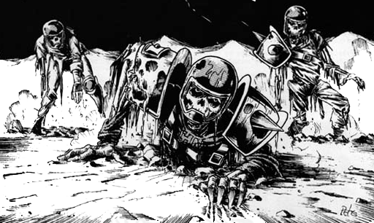

NAF Tournament Info
This is a NAF approved US Major tournament. If you wish to receive limited edition yearly gift and have your tournament progress tracked, there will be an NAF official onsite accepting registration for the cost of $5/year. More information can be found at TheNAF.net

Illegal Procedure
In the spirit of good sportsmanship, Illegal Procedures will not be called

Timing
The time limit WILL be strictly enforced. You will receive ‘Time Remaining’ updates from the Tournament Organizer to help you stay on pace.
When time is called, you will play to “even turns”. If you just started turn 7(for example), then you and your opponent each finish turn 7. If the active player is the last part of a turn, the game ends upon completion.
Intentionally stalling is not allowed by the coach (stalling with the team is fine), each turn should take roughly 4 minutes. If the organizer feels that someone is stalling, a 4 minute timer may be used.

Dice
You are required to share dice with your opponent if requested. Only the Nuffleween Tournament D6’s received at registration may be used. You and your opponent should decide whose set of dice will be used.

Scoring
During each round, you will fill out a score sheet to track your progress. At the end of the match, you will add up the scoring as follows:
- A WIN is worth 60pts
- A DRAW is worth 30pts
- A LOSS is worth 10pts
- If you lost by 1 Touchdown, you earn +2 bonus pts
- If you caused 1 more CAS from Blocking than opp you earn +2 bonus pts
- If you caused 2 or more CAS from Blocking than opp you earn +5 bonus pts
- If you clear the pitch you earn +5 bonus pts (Once per game)
- If you won by 2 Touchdowns you earn +2 bonus pts
- If you won by 3 or more Touchdowns you earn +5 bonus pts
- If you finished the game by using all turns +3 bonus pts

There is a no championship game the standings will solely be determined by total points

Overtime
There will be no overtime played. If your game ends in a draw, it’s draw.

Tiebreakers
The scoring system has been setup to hopefully get the most accurate representation of how everyone has performed. If, by chance there is a tie in Tournament points, the ties will be broken in this order:
- Winning Percentage
- Strength of Schedule for this tournament as determined by SCORE program
- Head to Head record for today (if applicable)
- Net TDs plus Net CAS
- Total TDs plus Total CAS
- Thriller Dance Off

If it is still a tie at that point, the tournament organizer will use his best judgment in finding a way to break the tie.

Painting
All teams are expected to meet the minimum painted guidelines. They must have 3 colors on them and have had some attempt at making them appear finished.

Sportsmanship
We are here for the fun of the game. Sportsmanship is not encouraged from the coaches it is required!
Fouling 16 turns in a row and running up the score is not poor sportsmanship, but gloating and ridiculing your opponent while doing so is.
Tournament Organizer will strictly enforce the “Don’t be a Douche” policy. Basically, it consists of not performing any acts of Douchebaggery.

Awards
In order to qualify for any award, the coach must complete all 4 rounds.
The following awards will be given out after the last round:
  - Nuffleween Champion - Team that has the most points after 4 rounds
  - 2nd Place -Team that has the 2nd most points after 4 rounds
  - Del Zine Cup (3rd Place) - Team that has the 3rd most points after 4 rounds
  - Best Offense - Team that scored the most TDs that did not place 1st - 3rd
  - Best Defense - Team that allowed the fewest TDs that did not place 1st - 3rd
  - Most Brutal - Team that inflicted the most Casualties from Blocking that did not place 1st - 3rd
  - Fan Favorite - Best fan favorite team as decided by the participants of the event. It could be based on anything, models, paint job, theme, your vote for the best team at the event.Tournament Organizer will break ties.
  - Best Sportsman - Best Sportsman as decided by participants. Tournament Organizer will break ties.
  - Stunty Cup - Stunty team with the most tournament points.
  - Back of the Pack - Coach that finished with lowest number of Tournament points.

Spread The Wealth
A coach may only win one award. If they are in line to win more than one award, they will be asked which one they would prefer and the next coach in line will be given the other award. Tournament organizers reserve the right to adjust the awards, i.e.Back of the Pack has to have played in all 4 rounds.

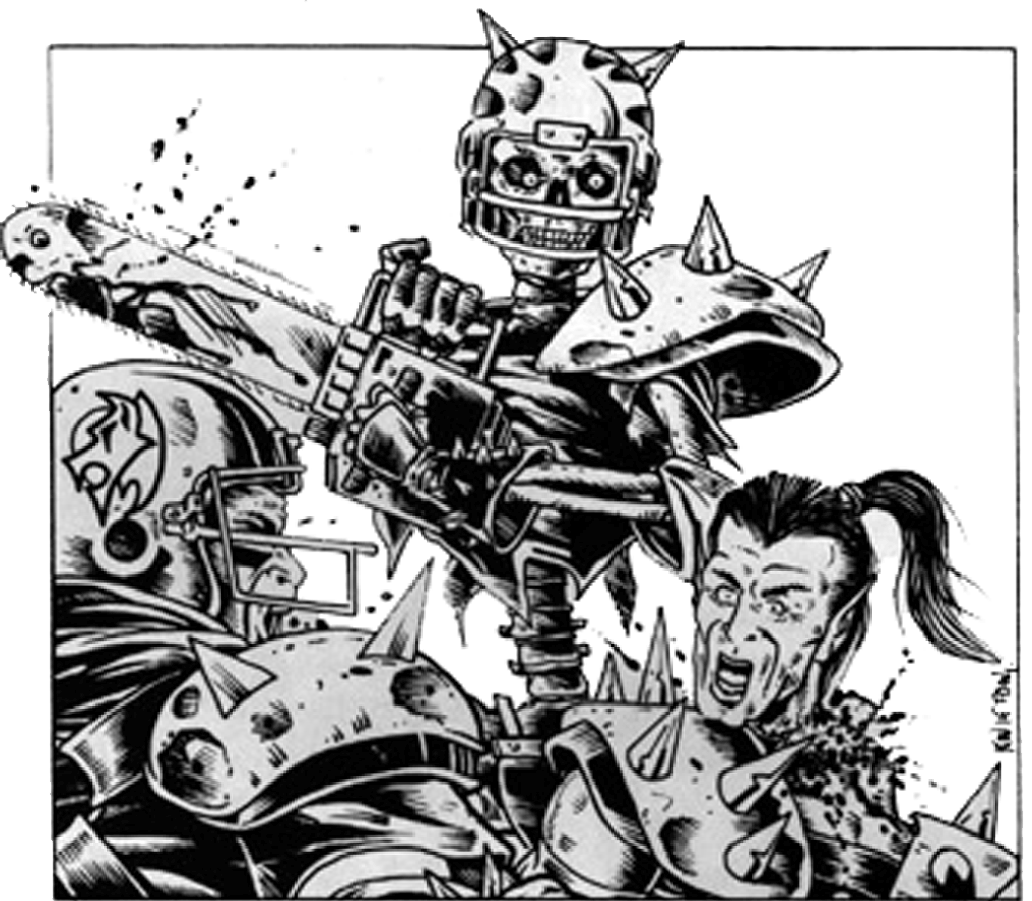

QUESTIONS? Email us at bothdownpodcast@gmail.com for Answers!

Nuffleween Special Stadiums (Random Pitches)

Palaces of Eternal Suffering - Chaos Chosen Pitch

Special Rules: Dark, Molten Lava, Normal Weather Chart

1st Half: Start on Dark side of pitch. If at any point during the 1st Half a player from either team is removed as a CAS for any reason, molten lava begins to bubble up and the pitch will be flipped over at half time.

2nd Half: If the pitch has been flipped over use the following rules: Sweltering Heat will be used as the weather result for the remainder of the game. If changing weather is rolled on the kick off table, just bounce the ball an extra square. All "Go For It" rolls fail on a 1 or 2 due the demonic hands trying to grab at the players through the cracks on the pitch as they move.

--------------------------------------------------------------------------------------------------------------------------------------

Longship Stadium - Dark Elf Corsair Pitch

Special Rules: Calm Deck, Submerging Deck, Normal Weather Chart

1st Half- Slippery Deck: All "Go For It" rolls fail on a 1 or 2 on squares within 3 spaces of either Sideline and the End Zones of the pitch. If the weather result is Pouring Rain then all "Go For It" rolls fail on a 1 or 2, on the entire pitch.

2nd Half- Submerging Deck: Flip pitch over to this side, the ship is sinking and the water it up to our ankles. All MV is capped at 6 (plus your 2 GFI).

--------------------------------------------------------------------------------------------------------------------------------------

Three Towers/Warpstone Coliseum - Dwarf/Skaven Pitch

Special Rules: Dwarf, Skaven

Roll a D6: If result is Odd Number Dwarf Pitch is used, if Even Skaven Pitch is used.

Dwarf Pitch Rules:

Weather is always Normal, no other special rules are used.

Skaven Pitch Rules:

Warpstone Sickness: The players all seem to be sick due the exposure to the Warpstone, after each TD or the end of the half roll a D6 for each player on the pitch. On a result of a 1 that player is in hurting and remains on the field in the stunned position to start the next drive.

--------------------------------------------------------------------------------------------------------------------------------------

The Vale - Elven Union Pitch

Special Rules: Frozen Pitch, Elven Union, Special Weather

1st Half- Frozen Pitch: Game starts with Blizzard for the starting weather and remains that way until a "Change of Weather" is rolled on the Kick-Off table. On the first "Change of Weather" result add +3 to the new result. All "Change of Weather" results after the first one is rolled as normal.

2nd Half- Frozen Pitch/Non Frozen Pitch: At the begging of the second half roll for new weather, this new result is used to start the next half. Weather rules for the rest of the game are normal.

--------------------------------------------------------------------------------------------------------------------------------------

Griswell Memorial Stadium - Human Pitch

Special Rules: None all rules are normal

--------------------------------------------------------------------------------------------------------------------------------------

Dinner Dome - Halfling Pitch

Special Rules: Green and Pleasant, Muddy Mess, Normal Weather Chart

1st Half: Game starts on the Green and Pleasant side of the pitch. If at any time there is a Riot result on the kick off table use the Muddy Mess pitch rules below. Continue on playing on this side of the pitch until a drive end, then play on the Muddy Mess side of the pitch for the remainder of the game.

Muddy Mess: Due to all the trash and holes caused by the Halflings in attendance, all "Go For It" rolls fail on a 1 or 2.

--------------------------------------------------------------------------------------------------------------------------------------

New Quetza Stadium - Lizardmen Pitch

Rules to come!

--------------------------------------------------------------------------------------------------------------------------------------

Papa Nurgle Suplex Field - Nurgle Pitch

Special Rules: Hibernating Garden, Blooming Garden, Normal Weather Chart

1st Half: Start on Hibernating Garden side of pitch. If at any point during the 1st Half a player from either team is removed as a CAS for any reason, Nurgle's blessings begin to grow and the pitch will be flipped over to the at Blooming Garden half time.

2nd Half: If the pitch has been flipped over to the Blooming Garden use the following rules. Due the masses of maggoty worms and daemonic plants the Pouring Rain weather result will be used for the remainder of the game. If changing weather is rolled on the kick off table, just bounce the ball an extra square. All players attempting to move more than 6 squares will have to make a "Go For It" roll for each square beyond the 6th square of movement.

--------------------------------------------------------------------------------------------------------------------------------------

Pain Park - Shambling Undead Pitch

Special Rules: Dusk, Darkness Falls, Normal Weather Chart

1st Half: Start on Dusk side of pitch. Due to the objects (graves, etc.) any player moving over 7 spaces must make a "Go For It" roll.

2nd Half: Flip the pitch over and start on Darkness Falls side of pitch. Due to the objects (graves, etc.) any player moving over 7 spaces must make a "Go For It" roll. In addition due to the misty fog only Quick and Short passes can be attempted.

--------------------------------------------------------------------------------------------------------------------------------------

Skull Stadium Pitch - Orc Field

Special Rules: None all rules are normal

--------------------------------------------------------------------------------------------------------------------------------------

Scarscrag Stadium - Waterlogged Stadium Pitch

Special Rules: Dry, Flooded Pitch, Unique Weather

2D6 Result

2-5 Dazzling Sun: The Sun is out and very bright. A -1 modifier to all pass rolls.

6-8 Light Drizzle: It's raining but not enough to effect the game. At the end of a drive or half if on the Dry Side roll a D6. On a result of 5 or 6 flip the board to the Flooded Side and use the Flooded Pitch Rules.

9-12 Brisk Downpour: A -1 modifier applies to all Catch, Intercept, and Pick-Up rolls. If the 1st half ends with this result flip the board to the Flooded Side at half time.

Flooded Pitch Rules: Whenever a player recovers from being Stunned, roll a D6. On the result of a 1 then that player stays face down in the water.

--------------------------------------------------------------------------------------------------------------------------------------

Athelorn Park - Wood Elf Pitch

Special Rules: Summer, Autumn, Normal Weather Chart

1st Half: Start on Summer side of pitch. All players can "Go For It" one extra square (3 instead of 2). At the end of the 1st half flip the board over to the Autumn side of the pitch.

2nd Half: Autumn uses the following rules: Subtract 1 from all Armour rolls as part of Block or Foul actions. Add 1 to all Knock Out recovery results (like a free Bloodweiser Keg).

--------------------------------------------------------------------------------------------------------------------------------------

Bluchen Bay Field - Winter Weather Pitch

Special Rules: Winter Weather Table:

2D6 Result

2 Howling Winds: The fans are shivering in the stands as a ferocious gale blows steadily down the pitch. Any pass attempts have an additional -1 modifier. Each player rolls a D6 (re-rolling ties) – the wind is blowing down the pitch towards the losing player’s End Zone. Whenever the ball scatters for a kick-off or inaccurate pass, it will be blown down the pitch. Before making the Scatter roll, place the Throw-in template over the ball so that the 3-4 result is pointing in the same direction as the wind, then roll a D6 and move the ball one space in the corresponding direction. Repeat this a second time, then scatter the ball as normal.

3 Freezing: A sudden cold snap turns the ground as hard as granite (and not the ‘astro’ variety that players are used to). Whenever a player is Knocked Down, add 1 to the result of the Armour roll.

4-10 Brisk: It’s rather chilly, but it is as close to perfect Blood Bowl weather as you can hope for at this time of year! This counts as a ‘Nice’ result for purposes of the Changing Weather result on the Kick-off table.

11 Heavy Snow: Visibility is low, it’s slippery underfoot and it’s impossible to spot tripping hazards, making it very difficult indeed to block effectively. Whenever a player makes a Blitz Action, their ST is reduced by 1 for the duration of that Action.

12 Blizzard: Between the snow, the wind and the icy ground, it is a miracle the game’s still in progress! Any player attempting to move an extra square (GFI) will slip and be Knocked Down on a roll of 1-2, and only Quick or Short Passes can be attempted.

--------------------------------------------------------------------------------------------------------------------------------------

