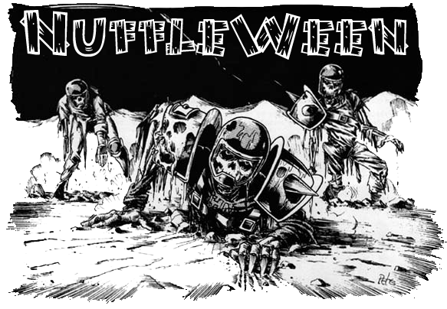
TOURNAMENT RULES PACK 1.0
2518

Nuffleween VII:
Sin-Sational!

November 10th, 2018 at Wizards Asylum
3717 W Main St. Norman, OK 73072

Cost
$30 at the door
$25 If you Pre-register by October 31st 2017 at website.

Things we will provide
Pen
Nametag
Match Sheet
Custom Dice
Awards

Pre-Registration Bonus
If you pre-register by October 31st will also get 2 additional Nuffleween D6’s, plus $5 off.

Tournament Schedule
8:00 – Registration Starts
8:15 – Registration Ends
8:30 – Round 1 (Random)
10:45 – Break
11:00 – Round 2 (Swiss)
1:15 – Lunch
2:15 – Round 3 (Swiss)
2:30 – Break
4:45 – Round 4 (Swiss/Finals)
7:00 – Break
7:15 – Results/Awards

What you should bring
- Your Painted Blood Bowl Team
- 5 copies of your roster (Click here for Blank Roster template)
- Blood Bowl Field/Dugouts/Templates
- Block Dice, D8 and Ball. The Both Down Kick-Off D2/D3 die is recommended.

Tournament Rules
- Per the NAF, the CRP version of Piling On will be used
- Roster changes in BB16, DZ1 and DZ2 are being used (ie – Humans, Orcs, Gobbos, etc)
- Any Star Players in the CRP, BB16, DZ1 or DZ2 are allowable. Grak and Crumbleberry are allowed using most recent rules
- Any optional rules (Refs, White Dwarf/Black Goblin, etc) will not be allowed
- Arguing the call - In order to be allowed to make use of this, you are required to have a fully painted head coach model that is thematically consistent with your team, is not a standard player model and has some indication of being a coach(hat, playbook, whip, etc). The determination of acceptable models is by the tournament organizer.

NuffleWeen Tournament Special Rules and Team Building

Special Weather Table (None) Players will use the normal weather for each game.

Nuffleween Kick-Off Table
There will be a Special Nuffleween kick-off table on the last page of this document (page 8) that will be used instead of the Normal Blood Bowl kick-off table.

Team Building Rules
You are given 1,100,000 gold pieces to build your team using CRP team lists or the three additional Team Lists. You may purchase players, rerolls, apothecary, fan factor, coaches, and cheerleaders as normal. You will be able to purchase skills later, see Additional Skills next page.

The only inducements allowed for purchase are Bribes, Halfling Chef, Star Players and Horatio X. Schottenheim from Death Zone 2.

CRP Star Players
Note: If you are including a regular Star Player from the CRP Rule Book, you must still have 11 players on your team BEFORE being able to hire them. Having 10 players plus a Star Player is NOT allowed. Unless that player is a Nuffleween Star Player.

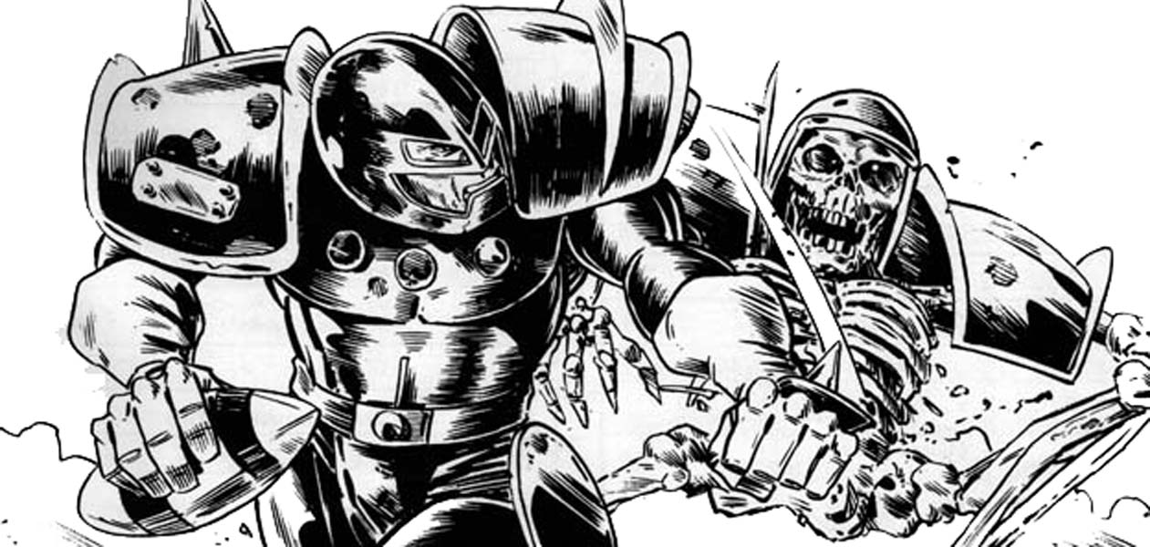

Nuffleween Special Star Players Rules
Any Nuffleween Star Player will count towards your 11 players needed for initial team creation. They still count as one of your 2 Star Players allowed on a team.
Note: You can purchase any of the Dead/Undead superstar’s listed in CRP Rules pack. The following players can be used on ANY team.
- Count Luthor Von Drakenborg
- Crazy Igor
- Hack Enslash
- Humerus Carpal
- Icatha Benoin
- J Earlice
- Ramtut III
- Setekh
- Sinnedbad
- Wilhelm Chaney

Each of these players will have Fan Favorite skill for free. The Fan Favorite will not stack for this tournament.

Rule for Multiple of the Same Star Player
This is a once in a lifetime event for most of the guys. As such, some players may pretend to be a Star Player or some of the smart ones will be cloned by Wizards to get double the pay. What does that that mean? Star Players may play for both teams as there is no “Highlander Rule”.

All Star Players follow the same rules that are in the CRP Rule Book. 0-2 Star Players may be purchased per team. Apothecaries cannot be used on Star Players

Additional Skills
After you build your team with the 1,100,000 gold pieces your team gets an additional 150K that you can choose to spend however you would want on skills for your team.

A normal skill upgrade costs 20,000
A doubles skill upgrade costs 30,000

You may only assign one additional skill per player, and no skill may be taken more than three times. You may not assign a skill to a Star Player.

All Injuries will reset as this is a Resurrection Tournament

“Trick” or “Treat” Tournament Rule

Before each round, Nuffle will give you either a “Trick” or a “Treat”. The 1st Round will be played as if Nuffle has given everyone a “Trick”. All skills lost during the Treat or Trick phase of the game are gone for the rest of the tournament, so choose wisely.

“Trick” – If you won or tied your last game, Nuffle will select a player at random that received a purchased skill and that player will lose that skill for the rest for the Tournament.

“Treat” – If you lost your last game, Nuffle will let you pick a player that received a purchased skill and that player will lose that skill for the rest for the Tournament.

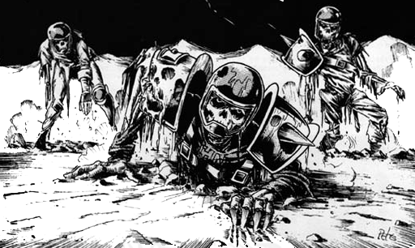

NAF Tournament Info
This is a NAF approved US Major tournament. If you wish to receive limited edition yearly gift and have your tournament progress tracked, there will be an NAF official onsite accepting registration for the cost of $5/year. More information can be found at TheNAF.net

Illegal Procedure
In the spirit of good sportsmanship, Illegal Procedures will not be called

Timing
The time limit WILL be strictly enforced. You will receive ‘Time Remaining’ updates from the Tournament Organizer to help you stay on pace.
When time is called, you will play to “even turns”. If you just started turn 7(for example), then you and your opponent each finish turn 7. If the active player is the last part of a turn, the game ends upon completion.
Intentionally stalling is not allowed by the coach (stalling with the team is fine), each turn should take roughly 4 minutes. If the organizer feels that someone is stalling, a 4 minute timer may be used.

Dice
You are required to share dice with your opponent if requested. Only the Nuffleween Tournament D6’s received at registration may be used. You and your opponent should decide whose set of dice will be used.

Scoring
During each round, you will fill out a score sheet to track your progress. At the end of the match, you will add up the scoring as follows:
- A WIN is worth 60pts
- A DRAW is worth 30pts
- A LOSS is worth 10pts
- If you lost by 1 Touchdown, you earn +2 bonus pts
- If you caused 1 more CAS from Blocking than opp you earn +2 bonus pts
- If you caused 2 or more CAS from Blocking than opp you earn +5 bonus pts
- If you clear the pitch you earn +5 bonus pts (Once per game)
- If you won by 2 Touchdowns you earn +2 bonus pts
- If you won by 3 or more Touchdowns you earn +5 bonus pts
- If you finished the game by using all turns +3 bonus pts
There is a no championship game the standings will solely be determined by total points

Overtime
There will be no overtime played. If your game ends in a draw, it’s draw.

Tiebreakers
The scoring system has been setup to hopefully get the most accurate representation of how everyone has performed. If, by chance there is a tie in Tournament points, the ties will be broken in this order:
- Winning Percentage
- Strength of Schedule for this tournament as determined by SCORE program
- Head to Head record for today (if applicable)
- Net TDs plus Net CAS
- Total TDs plus Total CAS
- Thriller Dance Off

If it is still a tie at that point, the tournament organizer will use his best judgment in finding a way to break the tie.

Painting
All teams are expected to meet the minimum painted guidelines. They must have 3 colors on them and have had some attempt at making them appear finished.

Sportsmanship
We are here for the fun of the game. Sportsmanship is not encouraged from the coaches it is required!
Fouling 16 turns in a row and running up the score is not poor sportsmanship, but gloating and ridiculing your opponent while doing so is.
Tournament Organizer will strictly enforce the “Don’t be a Douche” policy. Basically, it consists of not performing any acts of Douchebaggery.

Awards
In order to qualify for any award, the coach must complete all 4 rounds.
The following awards will be given out after the last round:
  - Nuffleween Champion - Team that has the most points after 4 rounds
  - 2nd Place -Team that has the 2nd most points after 4 rounds
  - Del Zine Cup (3rd Place) - Team that has the 3rd most points after 4 rounds
  - Best Offense Certificate - Team that scored the most TDs that did not place 1st - 3rd
  - Best Defense Certificate - Team that allowed the fewest TDs that did not place 1st - 3rd
  - Most Brutal Certificate - Team that inflicted the most Casualties from Blocking that did not place 1st - 3rd
  - Fan Favorite - Best fan favorite team as decided by the participants of the event. It could be based on anything, models, paint job, theme, your vote for the best team at the event. Tournament Organizer will break ties.
  - Best Sportsman - Best Sportsman as decided by participants. Tournament Organizer will break ties.
  - Stunty Cup Certificate – Stunty team with the most tournament points.
  - Back of the Pack - Coach that finished with lowest number of Tournament points.

Spread The Wealth
A coach may only win one award. If they are in line to win more than one award, they will be asked which one they would prefer and the next coach in line will be given the other award. Tournament organizers reserve the right to adjust the awards, i.e.Back of the Pack has to have played in all 4 rounds.

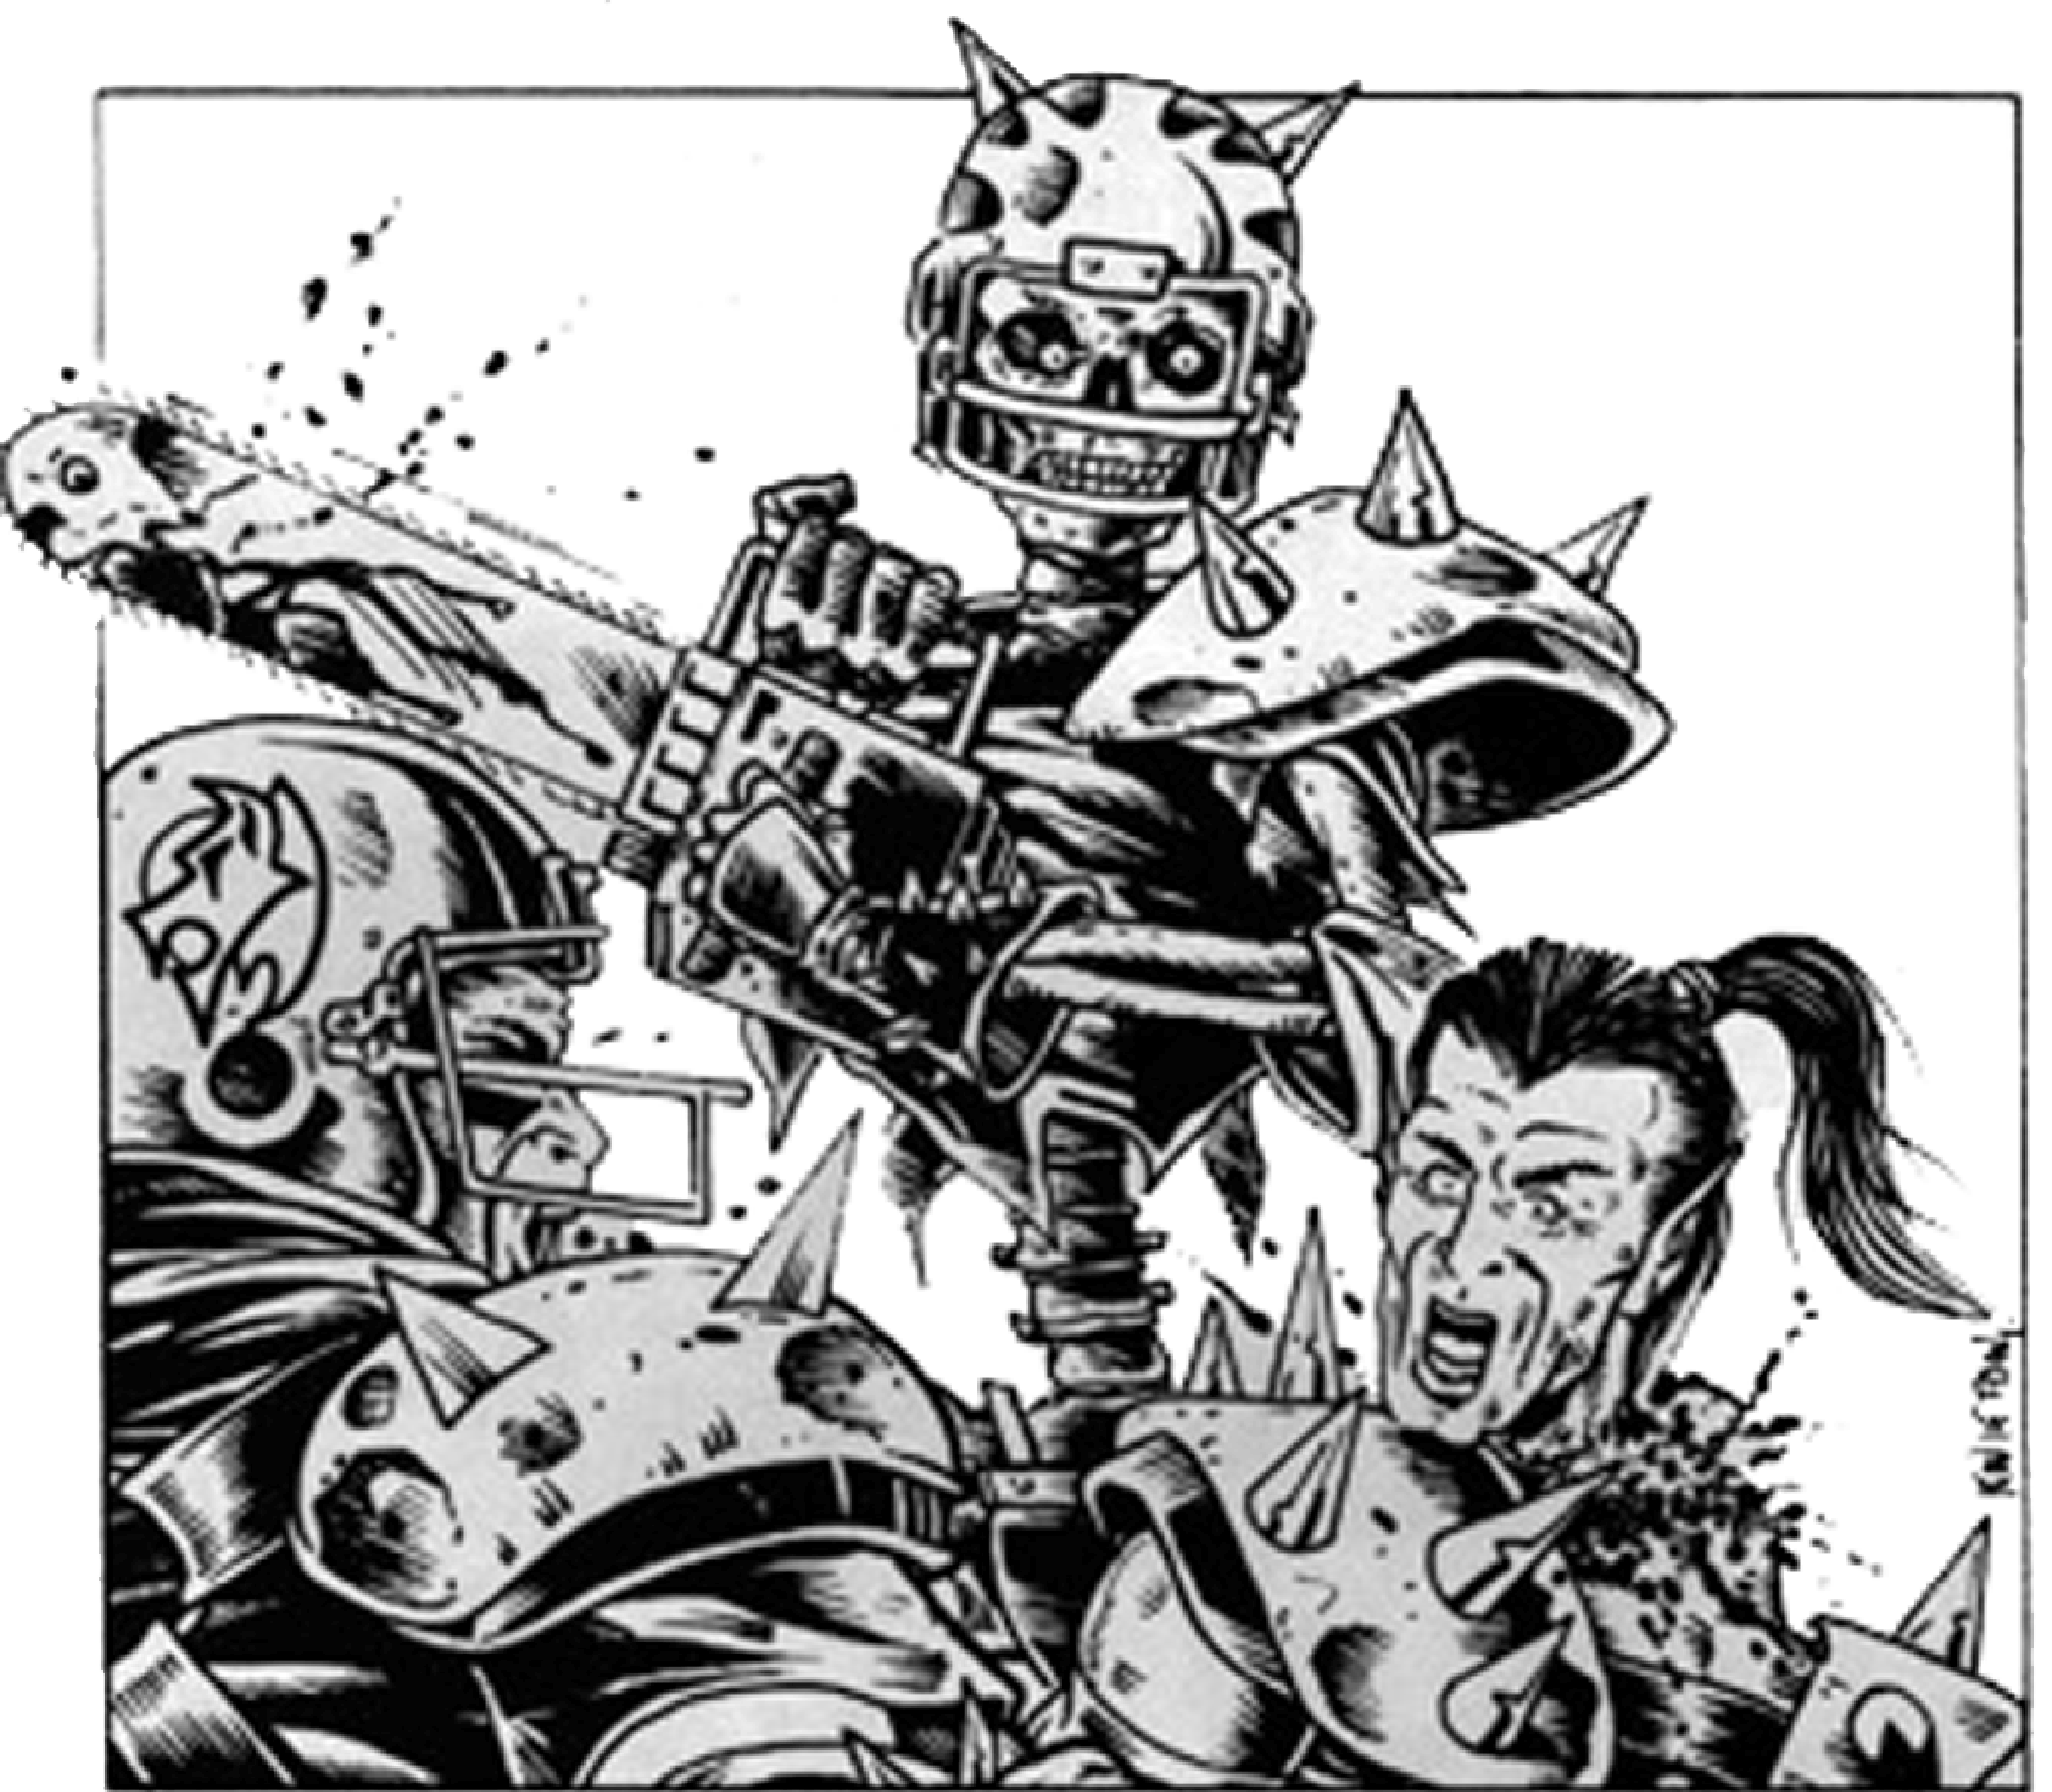

QUESTIONS? Email us at bothdownpodcast@gmail.com for Answers!

NUFFLEWEEN
KICK-OFF TABLE
2 | “Abandon All Hope…” – Nuffle has decreed that each team will be blessed with a free Bribe!
3 | Lust! – Nuffle curses each team with lust… BLOOD LUST! Give each player the skill Blood Lust for this drive. They may bite any player on their team. All players bitten this way will be stunned. No regular injury roll is needed. If nobody is bit, you go off pitch and turnover as normal. This effect will end if any of your players succumb to the Blood Lust and go off the field.
4 | Gluttony! – Nuffle empties each team’s stomachs! At the end of the drive, roll for each player. On a 1, that player may not set up for the next drive as they are gorging themselves in the locker room. If this occurs when Sweltering Heat is in play, reroll to get a different Kick-Off result.
5 | Greed! – Nuffle instills in each player a powerful greed! Should a player want more power, they need only make a sacrifice to Nuffle! Anytime this drive (on your turn), any player may sacrifice a team reroll to gain 1 ST or 1 AG. This may be done multiple times on separate turns. The increase lasts until the end of your turn only.
6 | Sintastic Cheers! – Each coach rolls a D6 adding FAME & Cheerleaders. Highest result gets a reroll.
7 | Path of the 7! – The weather changes. Each coach chooses a regular weather result they want. Then kicking team’s coach rolls a D3.  1) Go with the Receiving Player’s choice.  2) Go with the Kicking Player’s Choice.  3) Purgatory – A strange mist appears enveloping all within it! This mist is from another place and another time… and it’s hungry!  Roll a D6 for each player. On a 6 the player goes prone.  Roll a D6 for each player placed prone. On a 6, the player is stunned.  Roll a D6 for each player stunned. On a 6, the player is removed from the pitch.  Roll a D6 for each player removed. On a 6, the player is removed from this realm and is gone for the rest of the game (all others go to Reserves).  Roll a D6 for each player removed from the realm. On a 6, the player is lost forever and will not return to your team for the rest of this tournament.  Roll a D6 for each player lost forever. On a 6, destroy that figure and I’ll give you $5.  Roll a D6 for each player destroyed. On a 6, that player can come back into play on any game of your choice except your own. Players at that game will roll off to see who will control the returned player.
8 | Sintastic Coaching! – Each coach rolls a D6 adding FAME & Asst. Coaches. Highest result gets a bribe.
9 | Sloth! – Nuffle infects every player with Sloth! Any player, for this drive, that moves his full MA must roll a 2+ (before any Go For Its) or they lay down (No armor roll or turnover). Every GFI is a 4+.
10 | Wrath! – Nuffle brings out the Wrath in everyone! All players have Frenzy! (For this drive only.) They can fight the urge by rolling 3+ after the first block. If they fail, they must do Frenzy as normal. For this drive, anyone who has the Grab skill will have it replaced with the Juggernaut skill.
11 | Envy! – Nuffle fills each team with a strong streak of Envy! For this drive, each player gains the Pass Block and Strip Ball skill.
12 | Pride! – Nuffle has blessed all the players with pride in themselves! Blessed be they! For this drive, all players gain the skill Pride which works the same as Animosity, but instead of races, it’s for any other player. You may pick another target. If you fail that roll, you may repeat the process. You cannot target a previously targeted player. Rejoice!

