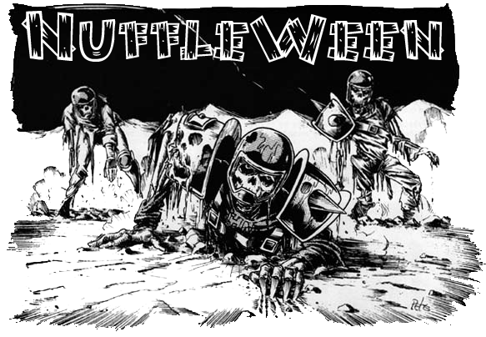
TOURNAMENT RULES PACK 1.2
2517

Nuffleween VI:
NUFFLE LIVES!

November 4th, 2017 at Wizards Asylum
749 South Jenkins Avenue. Norman, OK 73069

Cost
$30 at the door
$25 If you Pre-register by October 30th 2015 at website.

Things we will provide
Pen
Nametag
Match Sheet
Custom Dice
Awards

Pre-Registration Bonus
If you pre-register by October 31st will also get 2 additional Nuffleween D6’s, plus $5 off.

Tournament Schedule
8:00 – Registration Starts
8:15 – Registration Ends
8:30 – Round 1 (Random)
10:45 – Break
11:00 – Round 2 (Swiss)
1:15 – Lunch
2:15 – Round 3 (Swiss)
2:30 – Break
4:45 – Round 4 (Swiss/Finals)
7:00 – Break
7:15 – Results/Awards

What you should bring
- Your Painted Blood Bowl Team
- 5 copies of your roster (Click here for Blank Roster template)
- Blood Bowl Field/Dugouts/Templates
- Block Dice, D8 and Ball. The Both Down Kick Off D2/D3 die is recommended.
- Printed Copy of Competition Rules (CRP)/LRB6 can be found here-http://www.games-workshop.com/MEDIA_CustomProductCatalog/m780049a_Blood_Bowl_Competition_Rules.pdf
- Plus the three new teams listhttp://www.orclahomabowl.com/documents/New_Teams.pdf

Tournament Rules
- Per the NAF, the CRP version of Piling On will be used
- Roster changes in BB16, DZ1 and DZ2 are being used (ie – Humans, Orcs, Gobbos, etc)
- Any Star Players in the CRP, BB16, DZ1 or DZ2 are allowable. Grak and Crumbleberry are allowed using most recent rules
- Arguing the call - In order to be allowed to make use of this, you are required to have a fully painted head coach model that is thematically consistent with your team, is not a standard player model and has some indication of being a coach(hat, playbook, whip, etc). The determination of acceptable models is by the tournament organizer.
- Any optional rules (Refs, White Dwarf/Black Goblin, etc) will not be allowed
- Anything released post September 1st will not be allowed. If there are questions, email us.

NuffleWeen Tournament Special Rules and Team Building

Special Weather Table (None) Players will use the normal weather for each game.

Nuffleween Kick Off Table
There will be a Special Nuffleween Kick-off Table on the last page of this document (page 7) that will be used instead of the Normal Blood Bowl Kick-Off Table.

Team Building Rules
You are given 1,100,000 gold pieces to build your team using CRP team lists or the three additional Team Lists. You may purchase players, rerolls, apothecary, fan factor, coaches, and cheerleaders as normal. You will be able to purchase skills later, see Additional Skills next page.

The only inducements allowed for purchase are Bribes, Halfling Chef, Star Players and Horation X. Schottenheim from Death Zone 2.

CRP Star Players
Note: If you are including a regular Star Player from the CRP Rule Book, you must still have 11 players on your team BEFORE being able to hire them. Having 10 players plus a Star Player is NOT allowed.

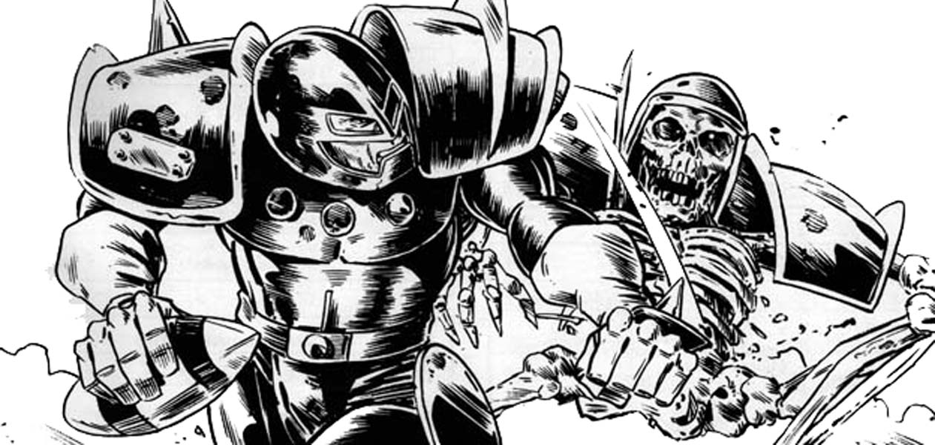

Nuffleween Special Star Players Rules
Note: You can purchase any of the Dead/Undead superstar’s listed in CRP Rules pack. The following players can be used on ANY team.
- Count Luthor Von Drakenborg
- Crazy Igor
- Hack Enslash
- Humerus Carpal
- Icatha Benoin
- J Earlice
- Ramtut III
- Setekh
- Sinnedbad
- Wilhelm Chaney

Each of these players will have Fan Favorite skill for free. The Fan Favorite will not stack for this tournament.

You DO NOT have to have 11 players in order to purchase a Nuffleween star player. If you purchase one CRP Star Player and one Nuffleween Star Player, you must have 11 regular team players first. Example: Having a Chaos Team with 10 players plus two of these Nuffleween Star Players is allowed. Any questions about this please email us at bothdownpodcast@gmail.com pleas put NUFFLEWEEN in Title of all emails.

Rule for Multiple of the Same Star Player
This is a once in a lifetime event for most of the guys. As such, some players may pretend to be a Star Player or some of the smart ones will be cloned by Wizards to get double the pay. What does that that mean? Star Players may play for both teams as there is no “Highlander Rule”.

All Star Players follow the same rules that are in the CRP Rule Book. 0-2 Star Players may be purchased per team.Apothecaries cannot be used on Star Players

Additional Skills
After you build your team with the 1,100,000 gold pieces your team gets an additional 150K that you can choose to spend however you would want on skills for your team.

A normal skill upgrade costs 20,000
A doubles skill upgrade costs 30,000

You may only assign one additional skill per player, and no skill may be taken more than three times. You may not assign a skill to a Star Player.

All Injuries will reset as this is a Resurrection Tournament

“Trick” or “Treat” Tournament Rule

Before each round, Nuffle will give you either a “Trick” or a “Treat”. If you won or tied your last game Nuffle will give you a “Trick”, if your last game was a loss Nuffle will give you a “Treat”. The 1st Round will be played as if Nuffle has given everyone a “Trick”. All skills lost during the Treat or Trick phase of the game are gone for the rest of the tournament so choose wisely.

“Trick” – If you won or tied your last game, Nuffle will select a player at random that received a purchased skill and that player will lose that skillfor the rest for the Tournament.

“Treat” – If you lost your last game, Nuffle will let you pick a player that received a purchased skill and that player will lose that skillfor the rest for the Tournament.

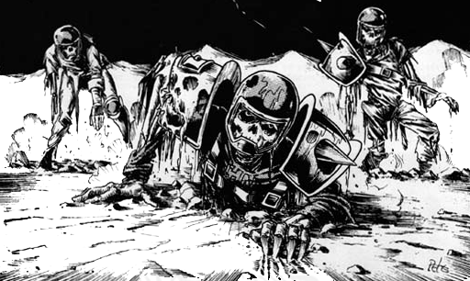

NAF Tournament Info
This is a NAF approved US Major tournament. If you wish to receive limited edition colored Block Dice and have your tournament progress tracked, there will be an NAF Official onsite accepting registration for the cost of $5/year. More information can be found at TheNAF.net

Illegal Procedure
In the spirit of good sportsmanship, Illegal Procedures will not be called

Timing
The time limit WILL be strictly enforced. You will receive ‘Time Remaining’ updates from the Tournament Organizer to help you stay on pace.

The 4 Minute turn rule will not be used unless the Tournament organizer feels your game is in danger of not completing in the two hour timelimit. He may insist on a timer being used and enforcing the 4 minute turn rule.

Dice
You are required to share dice with your opponent if requested. Only the Nuffleween Tournament D6’s received at registration may be used. You and your opponent should decide whose set of dice will be used.

Scoring
After each round you will fill out both the game sheet and the etiquette sheet based on the game just completed.
- A WIN is worth 60pts
- A DRAW is worth 30pts
- A LOSS is worth 10pts
- If you lost by 1 Touchdown, you earn +2 bonus pts
- If you caused 1 more CAS from Blocking than opp you earn +2 bonus pts
- If you caused 2 or more CAS from Blocking than opp you earn +5 bonus pts
- If you clear the pitch you earn +5 bonus pts
- If you won by 2 Touchdowns you earn +2 bonus pts
- If you won by 3 or more Touchdowns you earn +5 bonus pts
- If you finished the game by using all turns +3 bonus pts

There is a no championship game the standings will solely be determined by total points

Overtime
There will be no overtime played. If your game ends in a draw, it’s draw.

Tiebreakers
The Scoring system has been setup to hopefully get the most accurate representation of how everyone has per-formed. If, by chance there is a tie in Tournament points, the ties will be broken in this order:
- Total Points
- Winning Percentage
- Strength of Schedule
- Head to Head record
- Net TDs plus Net CAS
- Total TDs plus Total CAS
- Thriller Dance Off

If it is still a tie at that point, the tournament organizer will use his best judgment in finding a way to break the tie.

Painting
All teams are expected to meet the minimum painted guidelines. They must have 3 colors on them and have had some attempt at making them appear finished.

Sportsmanship
We are here for the fun of the game. Sportsmanship is not encouraged from the coaches it is required!

Fouling 16 turns in a row and running up the score is not poor sportsmanship, but gloating and ridiculing your opponent while doing so is.

Sportsmanship Awards will be determined based on answers given in the Etiquette Sheet.

Tournament Organizer will strictly enforce the “Don’t be a Douche” policy. Basically, it consists of not performing any acts of Douchebaggery.

Awards
In order to qualify for any award, the coach must complete all 4 rounds.
The following awards will be given out after the last round:
  - NuffleWeen Champion - Team that has the most points after 4 rounds
  - 2nd Place -Team that has the 2nd most points after 4 rounds
  - Del Zine Cup (3rd Place) - Team that has the 3rd most points after 4 rounds
  - Best Offense Certificate - Team that scored the most TDs that did not place 1st - 3rd
  - Best Defense Certificate - Team that allowed the fewest TDs that did not place 1st - 3rd
  - Most Brutal Certificate - Team that inflicted the most Casualties from Blocking that did not place 1st - 3rd
  - Fan Favorite - Best fan favorite team as decided by the participants of the event. It could be based on anything, models, paint job, theme, your vote for the best team at the event.
  - Best Sportsman - Best Sportsman as decided by participants. Tournament Organizer will break ties.
  - Stunty Cup Certificate - Highest ranked stunty team at the tournament
  - Back of the Pack - Coach that finished with lowest number of Tournament points.

Spread The Wealth
A coach may only win one award. If they are in line to win more than one award, they will be asked which one they would prefer and the next coach in line will be given the other award. Tournament organizers reserve the right to adjust the awards, i.e.Back of the Pack has to have played in all 4 rounds.

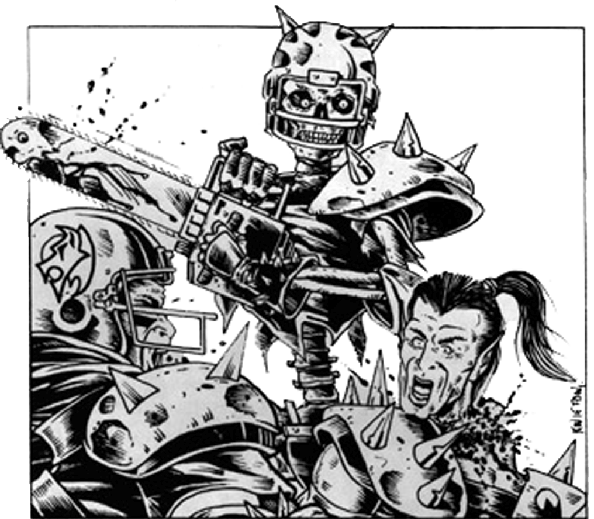

QUESTIONS? Email us at bothdownpodcast@gmail.com for Answers!

NUFFLEWEEN
KICK-OFF TABLE
2 | “He’s Back!” – The clouds gather and a bolt of lightning strikes a fallen player! Each coach can choose a player in the Dead/Injured box and Roll a D3:  1) The player is charred. They gain +1 to AV for any remaining games.  2) No Effect.  3) The player is revived/healed. They may take the field immediately. Place in any square in front of the Dead/Injured box. This may take you above 11 players for the drive.  If no player is in the box, the lightning hits the stands and the fans scatter. Move both teams to -1 FAME.
3 | “Man Behind The Mask!” – Each coach rolls a D6 adding FAME. Highest result (Or both if tied) will give a player a mask. The mask hides their identity, so they can remove it to confuse the ref. (Automatic Bribe)
4 | “Get That Guy!” – One player from the receiving team may perform a Blitz Action before the ball lands
5 | “Ch-ch-ch Ah-ah-ah!” – If either team has cheerleaders, they mysteriously vanish. If you lost any cheerleaders, roll a D6 adding FAME. On a 4+, you gain a reroll.
6 | “Be Careful!” – Each coach rolls a D6 adding FAME and Cheerleaders. Highest result gets bribe.
7 | “Lake Effect Weather!” – The weather changes. Each coach chooses a regular weather result they want. Then kicking team’s coach rolls a D3.  1) Go with the Receiving Player’s choice.  2) Go with the Kicking Player’s Choice.  3) Fog – An eerie fog rolls in from the lake close by… Only Short and quick passes are allowed. -1 to catches from Short passes. Change Machete to +3 to AV or +1 to Injury.
8 | “I’ve Got This!” – Each coach rolls a D6 adding FAME and Asst. Coaches. Highest result gets bribe.
9 | “A Child’s Innocence!” – If either team has a Machete, the other team may choose one player to be protected from it. If neither team has it, then reroll the Kick Off Table.
10 | “That Guy’s Crazy!” – One player from the kicking team may perform a Blitz Action before the ball lands
11 | “The Machete!” – Each coach rolls 2D6 and adds FAME. The coach with the highest result gives a machete to one of their players. The Machete gives the player Secret Weapon and Stab with a +1 to either the armor or the injury roll. This player may keep the Machete for any remaining games. Lose it when put in Dead/Inj box.
12 | “Triple Skull Attack!” – Ready? Roll! Count to three and then each player rolls 1 Block Die as fast as they can until they get a Skull. Then repeat until one person wins 3 times. That player gains a reroll.

