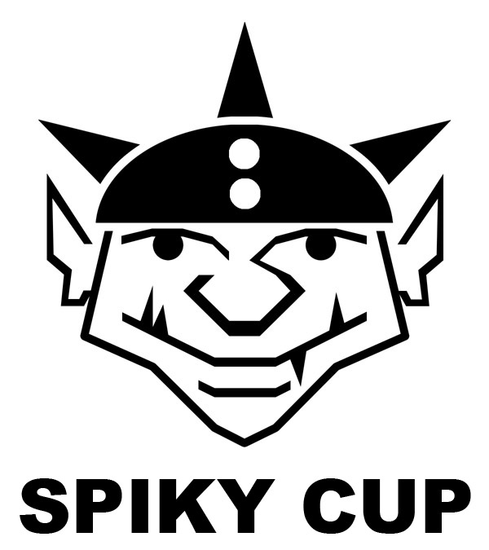

TOURNAMENT RULES PACK 1.0

Spiky Cup 5.5

June 24th at Wizards Asylum
749 South Jenkins Avenue. Norman, OK 73069

Cost

EARLY BIRD SPECIAL Pre-register by June 17, 2017
- $10 - Spiky Cup

REGULAR Pre-register by June 23, 2017 or AT THE DOOR
- $15 - Spiky Cup

All Events can be signed up and paid for at the BothDown.com/Spiky55

Rosters
All players that pre-register for Spiky Cup are required to send in their Roster by June 21, 2017. Players can email their Roster to OrclahomaBowl@gmail.com

Tournament Schedule
9:00 – Registration Starts
9:15 – Registration Ends
9:30 – Round 1 (Random)
11:30 – Break
12:30 – Round 2 (Swiss)
2:45 – Round 3 (Swiss)
5:00 – Results/Awards

What you should bring
- Your Painted Blood Bowl Team
- Four Copies of your team roster
- Blood Bowl Field/Dugouts/Templates
- Block Dice & D8
- Printed Copy of Competition Rules (CRP)/LRB6 can be found here- http://www.games-workshop.com/MEDIA_CustomProductCatalog/m780049a_Blood_Bowl_Competition_Rules.pdf
- Plus the three new teams list http://www.orclahomabowl.com/documents/New_Teams.pdf

Things we will provide
- Pen
- Nametag
- Match Sheet
- Custom Dice
- Awards

Special Weather table (None, That is Orclahoma Bowl! All tables roll their own weather)

Special Rules
- No cards will be used
- No special pitch rules will be used
- Ref rules, Head Coach Rules, and any rules not in CRP, BB16 or DZ1 are not allowed
- See below for clarification on Star Players that are allowed

Team Building Rules
- Each team will be given 1 free bribe (this is in addition to the 3 you can normally buy)
- You will choose a Sponsorship from the Sponsorship List below.
- You are given 1,300,000 gold pieces to build your team using CRP team lists or the three additional Team Lists.
- You may purchase players, rerolls, fan factor, coaches, and cheerleaders as normal.
- Star Players are the ones listed in the CRP and ONLY the following: Bilerot Vomitflesh, Frank N Stein, Rasta Tailspike and Guffle Pussmaw. No other stars will be allowed.
- Wizards, Journeymen, Special Play cards, and Mercenaries are NOT ALLOWED.
- With that said, you may purchase any other inducements as part of your team built.

Skills
You may use up to 300k from your build total to purchase and add skills as you see fit.
No more than 10 skills in total can be taken.
Regular skills are 20k and doubles are 30k (Except for stunty teams who may buy double skills for 20k).
Spiky Norman is a crazy Goblin so there is no one skill per player limit. Choose wisely.
SPECIAL SKILL INFO: Piling On uses the same rules as CRP, not as stated in the BB2016 Rules.
You may not give skills to Star Players.
Crazy 2nd Fifth Anniversary Spectacular!!!!!
The goblins are kinda dumb and want to have another party.
Each team must choose a sponsorship from the Sponsorship List section for their team.
There will be special events each round and Crom got confused and decided to come watch and be a general pain, as such, there is a custom kick off table to be used for this event!

Sponsorship List
This year, in addition to your team building rules previously discussed, each team gets to pick 1 sponsor for their team. This sponsor will be sending a special pair of boots to the teams that pick them. These special shoes are meant for regular players only, no Star Players or Big Guys (Anyone with 5+ St).
While the shoes were meant to be normal, each company wants to best the other, so they've sent enchanted shoes that imbue the player wearing them with extra skills.

Choose from one of the following:
- Spike - Sneaky Git, Dirty Player – “New for Spiky Cup, the new Spiky Spike Spiked boots!”
- Orcidas - Stand Firm, Juggernaut – “Put a little Orc in you with Orcidas!”
- Nuffle-Balance - Shadowing, Diving Tackle – “When you don't want them getting away, get Nuffle-Balance!”
- ‘Zonverse - Kick, Kick Off Return – “Made for a lady, but hardy enough for a Norse!”
- Jordells - Leap, Side Step – “Freshbreeze's secret? It's gotta be the boots!”
- DK- Swiss - Disturbing Presence, Fend – “Undead tested, Nurgle approved! Put some DK in your Decay”

CRP Star Players
Note: If you are including a Star Player from the CRP Rule Book, you must still have 11 players on your team BEFORE being able to hire them. Having 10 plus a Star is not allowed.

Rule for Multiple of the Same Star Player
This is a once in a lifetime event for most of the guys. As such, some players may pretend to be a Star Player or some of the smart ones will be cloned by Wizards to get double the pay. What does that that mean? Star Players may play for both teams. There will is no “Highlander Rule”.
NAF Tournament Info
This is an NAF approved tournament. You may register onsite for $5.
More information can be found at TheNAF.net

Illegal Procedure
In the spirit of good sportsmanship, Illegal Procedures will not be called

Timing
The time limits WILL be strictly enforced. You will receive ‘Time Remaining’ updates from the Tournament Organizer to help you stay on pace.

The 4 Minute turn rule will not be used unless the Tournament organizer feels your game is in danger of not completing in the two hour time limit. He may insist on a timer being used and enforcing the 4 minute turn rule.

Dice
Only the Spiky Cup D6’s received at registration may be used. You are encouraged to share dice with your opponent. You and your opponent should decide whose set of dice will be used.

Scoring
After each round you will fill out the game sheet based on the game just completed.
- ALL KNOCK OUTS from Blocking, Fouling, Crowd Surfing, Weapons etc will provide 2pts (Not for failing GFI or Dodges)
- ALL CASUALTIES from Blocking, Fouling, Crowd Surfing, Weapons etc will provide 4pts (Not for failing GFI or Dodges)
- A WIN is worth 60pts
- A DRAW is worth 30pts
- A LOSS is worth 10pts
- If you lost by 1 Touchdown, you earn +2 bonus pts
- If you caused 1 more CAS from Blocking than opp you earn +2 bonus pts
- If you caused 2 or more CAS from Blocking than opp you earn +5 bonus pts
- If you clear the pitch you earn +5 bonus pts (max once per game)
- If you won by 2 Touchdowns you earn +2 bonus pts
- If you won by 3 or more Touchdowns you earn +5 bonus pts
- If you finished the game by using all turns +3 bonus pts

Overtime
There will be no overtime played. If your game ends in a draw, it’s draw.

Tiebreakers
Goblins love causing chaos, cheating and mayhem. If by chance there is a tie in Tournament points, the ties will be broken in this order:
- Goblin Team wins tiebreaker against over any other team
- Most Casualties
- Most Casualties + Knock Outs
- Whoever pays the organizer the most
- Knife fight (Goblin Style)

Painting
All teams are expected to meet the minimum painted guidelines. They must have 3 colors on them and have had some attempt at making them appear finished.

Sportsmanship
We are here for the fun of the game. Sportsmanship is not encouraged from the coaches, it is required!
Fouling 16 turns in a row and running up the score is not poor sportsmanship, but gloating and ridiculing your opponent while doing so is.

Sportsmanship Awards will be determined based on answers given in the Etiquette Sheet.
Tournament Organizer will strictly enforce the “Don’t be a Douche” policy. Basically, it consists of not performing any acts of Douchebaggery.

Awards
The following certificates will be given out after the last round:
- Spiky Cup Champion - First Place Team in standings with the most overall points after 3 rounds.
- 2nd Place - Second Place team in standings with the most overall points after 3 rounds
- Del Zine Cup - Third Place team in standings with the most overall points after 3 rounds
- Best Offense - Team that scored the most TDs
- Best Defense - Team that allowed the fewest TDs
- Most Brutal - Team with the most KO and CAS bonus points
- Stunty Champion - Best Stunty Team (Halflings, Goblins, Ogre) in standings with the most overall points
- Fan Favorite - Best fan favorite team as decided by the participants of the event. It could be based on anything, your vote for the best team at the event.
- Best Sportsman - Best Sportsman as decided by participants via Etiquette sheet. Tournament Organizer will break ties.
- Back of the Pack - Coach that finished with lowest number of Tournament pts

Spread The Wealth
A coach may only win one award. If they are in line to win more than one award, they will be asked which one they would prefer and the next coach in line will be given the other award. Tournament organizers reserve the right to adjust the awards, ie Back of the Pack has to have played in all 3 rounds.

QUESTIONS? Email us at OrclahomaBowl@gmail.com for Answers!

 | Spiky Cup Kick-Off
2 | Crom is Ref - Crom in his drunken state decides he'd make a good ref. Roll a D3. Highest result gets a bribe. Add 1 for stunty teams. Both teams get bribe if tied.
3 | Crom score! - Crom wakes from his drunken stupor and decides he's going to score. He runs on to the field, grabs the ball and goes to the end zone and spikes it. As he celebrates, the clock runs forward one turn for each player even if it ends the game. Re-kick the ball and get another (not this) kick off result unless the game ended.
4 | Crom no like offense - Crom has decided he doesn't like the kicking team's set up. Receiving team gets to rearrange the players on the line of the kicking team into another legal position.
5 | Crom make funny - Like a regular high kick, however, you MUST position a player on the receiving team, that's not on the line, under the ball. Crom decides it'd be funny to run onto the pitch and block the player. Resolve as a ONE DIE block with no assists (player stays in square if fallen). Crom runs off after resolution. KO or Cas against Crom counts for the player.
6 | Crom like pretty ladies - Crom has distracted the cheerleaders. Each player rolls a D3 and adds Cheerleaders, Fame and +1 for stunty teams. Highest result gets a reroll. If tied, Crom gets confused and NEITHER team gets a reroll.
7 | Crom say change weather! - Crom has become buddies with a Weather Wizard and has decided that he's going to decide the weather. Each player chooses a weather result. Roll a D3 to see which happens. 1) Kicker's choice 2) Receiver's Choice 3) Eclipse - Crap it's dark. -1 to passing and the ref can't see any fouls (does not affect Secret Weapons).
8 | Crom best friend coach - Crom has distracted the assistant coaches. Each player rolls a D3 and adds coaches, Fame and +1 for stunty teams. Highest result gets a reroll. If tied, Crom gets confused and NEITHER team gets a reroll.
9 | Crom no like defense - Crom has decided he doesn't like the receiving team's set up. Kicking team gets to rearrange the players on the line of the receiving team into another legal position.
10 | Crom want kick ball - Crom comes from the sidelines and runs straight for the kicker. Find a random(unless a player is using the kick skill) kicking player not on the line. Resolve as a ONE DIE block with no assists(player stays in square if fallen). Crom runs off after resolution. KO or Cas against him counts for the player.
11 | Crom throw shiny rock - Crom feels something weird in his pants. He grabs the hard thing, whips it out and throws it on the field. Roll a D3. 1) Hits the kicking team 2) Hits the receiving team 3) Hits neither.  Choose a player randomly on the team indicated by the die. The rock gets embedded in the players head. They get KO'ed, but since it's a warpstone, they get a random mutation that lasts the rest of the tournament.  Mutations: 1) Claws, 2) Extra Arms, 3) Horns, 4) Prehensile Tail, 5) Tentacles, 6) Two Heads.
12 | Crom love riot! - For each player on the pitch, roll a D3. 1) No effect. 2) Player is prone. 3) Player is stunned.

