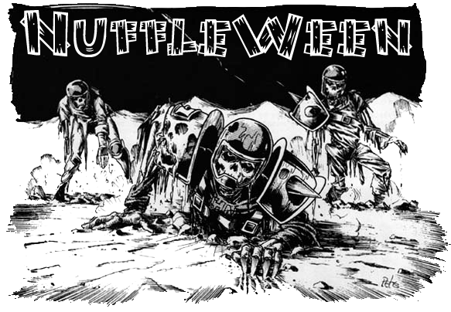
TOURNAMENT RULES PACK 1.0
2516

NuffleWeenV:
Hot Rot's
Block ‘n’ Wrestling!

November 5th, 2016 at Wizards Asylum
749 South Jenkins Avenue. Norman, OK 73069

Cost
$25 at the door
$20 If you Pre-register by October30th 2015 at website.

Things we will provide
Pen
Nametag
Match Sheet
Custom Dice
Awards
Nuffleween Candy

Pre-Registration Bonus
If you pre-register by October 30th will also get 2 additionalNuffleWeen D6’s (the rarer alternative pair), plus $5 off.

Tournament Schedule
8:00 – Registration Starts (Donuts will be provided for Breakfast!)
8:15– Registration Ends
8:30– Round 1 (Random)
10:45 – Break
11:00 – Round 2 (Swiss)
1:15 – Lunch
2:15– Round 3 (Swiss)
2:30– Break
4:45– Round 4 (Swiss/Finals)
7:00– Break
7:15– Results/Awards

What you should bring
- Your Painted Blood Bowl Team
- Only bring rosters IFyou don't pre-register. We will print off Pre-Registered Rosters(Click here for Blank Roster template)
- Blood Bowl Field/Dugouts/Templates
- GW or NAF Block Dice & D8
- Printed Copy of Competition Rules (CRP)/LRB6 can be found here-http://www.games-workshop.com/MEDIA_CustomProductCatalog/m780049a_Blood_Bowl_Competition_Rules.pdf
- Plus the three new teams listhttp://www.orclahomabowl.com/documents/New_Teams.pdf

NuffleWeen Tournament Special Rules and Team Building

Special Weather Table (None)
Players will use the normal weather for each game.

NuffleWeen Kick Off Table
There will be a Special NuffleWeen Kick-off Table on the last page of this document (page 7) that will be used instead of the Normal Blood Bowl Kick-Off Table.

Team Building Rules
You are given 1,100,000 gold pieces to build your team using CRP team lists or the three additional Team Lists. You may purchase players, rerolls, apothecary, fan factor, coaches, and cheerleaders as normal. You will be able to purchase skillslater, see Additional Skills next page.

Journeymen, Special Play cards, and Mercenaries are NOT ALLOWED. With that said, you may purchase any other inducements as part of your team built.

NOTE: A single WIZARD may be purchased for 100K but may ONLY use the Fireball Spell.

CRP Star Players
Note: If you are including a regular Star Player from the CRP Rule Book, you must still have 11 players on your team BEFORE being able to hire them. Having 10 players plus a Star Player is NOT allowed.

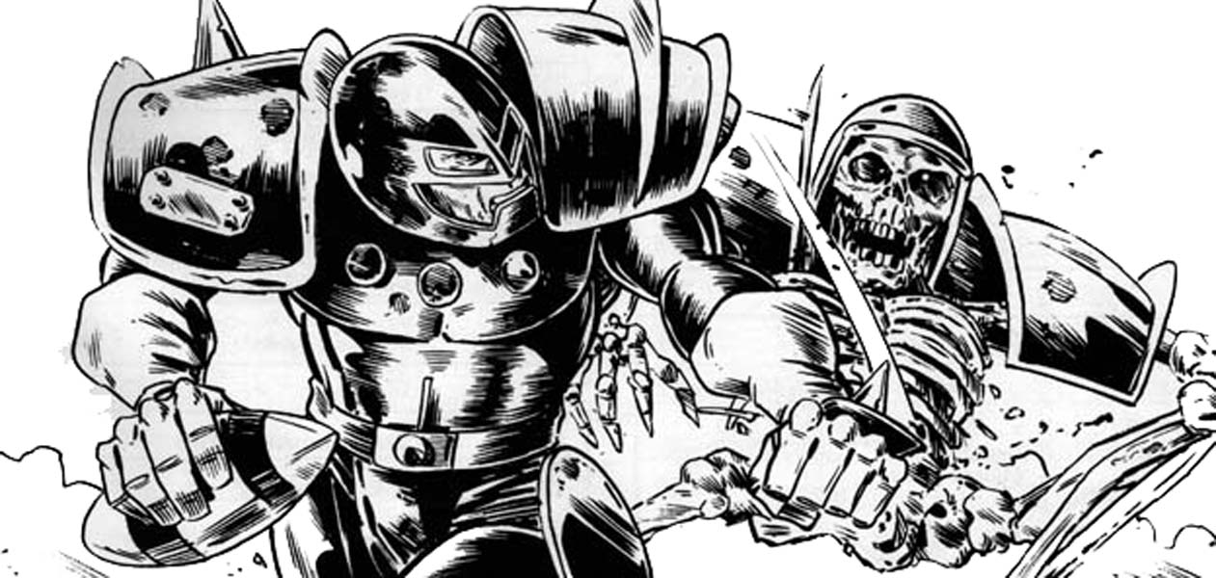

NuffleWeenSpecial Star Players Rules
Note: You can purchase any of the Dead/Undead superstar’s listed in CRP Rules pack. The following players can be used on ANY team.
- Count Luthor Von Drakenborg
- Crazy Igor
- Hack Enslash
- Humerus Carpal
- IcathaBenoin
- J Earlice
- Ramtut III
- Setekh
- Sinnedbad
- Wilhelm Chaney

Each of these players will have Fan Favorite skill for free. The Fan Favorite will not stack for this tournament.

You DO NOT have to have 11 players in order to purchase a NuffleWeen star player. If you purchase one CRP Star Player and one NuffleWeen Star Player, you must have 11 regular team players first. Example: Having a Chaos Team with 10 players plus two of these NuffleweenStar Players is allowed. Any questions about this please email us at bothdownpodcast@gmail.com pleas put NUFFLEWEEN in Title of all emails.

Rule for Multiple of the Same Star Player
This is a once in a lifetime event for most of the guys. As such, some players may pretend to be a Star Player or some of the smart ones will be cloned by Wizards to get double the pay. What does that that mean? Star Players may play for both teams as there is no “Highlander Rule”.

All Star Players follow the same rules that are in the CRP Rule Book. 0-2 Star Players may be purchased per team.Apothecaries cannot be used on Star Players

Additional Skills
After you build your team with the 1,100,000 gold pieces your team gets an additional 150K that you can choose to spend however you would want on skills for your team.

A normal skill upgrade costs 20,000
A doubles skill upgrade costs 30,000

You may only assign one additional skill per player, and no skill may be taken more than three times. You may not assign a skill to a Star Player.

All Injuries will reset as this is a Resurrection Tournament

“Trick” or “Treat” Tournament Rule

Before each round,Nuffle will give you either a “Trick” or a “Treat”. If you won or tied your last game Nuffle will give you a “Trick”, if your last game was a loss Nuffle will give you a “Treat”. The 1st Round will be played as if Nuffle has given everyone a “Trick”. All skills lost during the Treat or Trick phase of the game are gone for the rest of the tournament so choose wisely.

“Trick” – If you won or tied your last game,Nuffle will select a player at random that received a purchased skill and that player will lose that skillfor the rest for the Tournament.

“Treat” – If you lost your last game, Nuffle will let you pick a player that received a purchased skill and that player will lose that skillfor the rest for the Tournament.

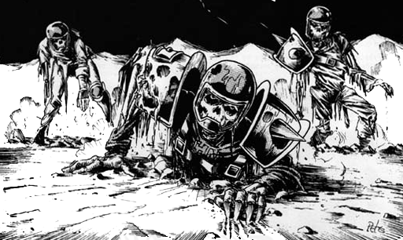

NAF Tournament Info
This is a NAF approved US Major tournament. If you wish to receive limited edition colored Block Dice and have your tournament progress tracked, there will be an NAF Official onsite accepting registration for the cost of $10/year. More information can be found at TheNAF.net

Illegal Procedure
In the spirit of good sportsmanship, Illegal Procedures will not be called

Timing
The two hour rounds WILL be strictly enforced. You will receive ‘Time Remaining’ updates from the Tournament Organizer to help you stay on pace.

The 4 Minute turn rule will not be used unless the Tournament organizer feels your game is in danger of not completing in the two hour timelimit. He may insist on a timer being used and enforcing the 4 minute turn rule.

Dice
You are required to share dice with your opponent. Only GW or NAF Block Dice may be used and only the NuffleWeen Tournament D6’s received at registration may be used. You and your opponent should decide whose set of dice will be used.

Scoring
After each round you will fill out both the game sheet and the etiquette sheet based on the game just completed.
- A WIN is worth 60pts
- A DRAW is worth 30pts
- A LOSS is worth 10pts
- If you lost by 1 Touchdown, you earn +2 bonus pts
- If you caused 1 more CAS from Blocking than opp you earn +2 bonus pts
- If you caused 2 or more CAS from Blocking than opp you earn +5 bonus pts
- If you clear the pitch you earn +5 bonus pts
- If you won by 2 Touchdowns you earn +2 bonus pts
- If you won by 3 or more Touchdowns you earn +5 bonus pts
- If you finished the game by using all turns +3 bonus pts

There is a no championship game the standings will solely be determined by total points

Overtime
There will be no overtime played. If your game ends in a draw, it’s draw.

Tiebreakers
The Scoring system has been setup to hopefully get the most accurate representation of how everyone has per-formed. If, by chance there is a tie in Tournament points, the ties will be broken in this order:
- Total Points
- Winning Percentage
- Strength of Schedule
- Head to Head record
- Net TDs plus Net CAS
- Total TDs plus Total CAS

If it is still a tie at that point, the tournament organizer will use his best judgment in finding a way to break the tie.

Painting
All teams are expected to meet the minimum painted guidelines. They must have 3 colors on them and have had some attempt at making them appear finished.

Sportsmanship
We are here for the fun of the game. Sportsmanship is not encouraged from the coaches it is required!

Fouling 16 turns in a row and running up the score is not poor sportsmanship, but gloating and ridiculing your opponent while doing so is.

Sportsmanship Awards will be determined based on answers given in the Etiquette Sheet.

Tournament Organizer will strictly enforce the “Don’t be a Douche” policy. Basically, it consists of not performing any acts of Douchebaggery.

Awards
The following awards will be given out after the last round:
  - NuffleWeen Champion - Team that has the most points after 4 rounds
  - 2nd Place -Team that has the 2nd most points after 4 rounds
  - Del Zine Cup (3rd Place) - Team that has the 3rd most points after 4 rounds
  - Best Offense Certificate - Team that scored the most TDs that did not place 1st - 3rd
  - Best Defense Certificate - Team that allowed the fewest TDs that did not place 1st - 3rd
  - Most Brutal Certificate - Team that inflicted the most Casualties from Blocking that did not place 1st - 3rd
  - Fan Favorite - Best fan favorite team as decided by the participants of the event. It could be based on anything, models, paint job, theme, your vote for the best team at the event.
  - Best Sportsman - Best Sportsman as decided by participants. Tournament Organizer will break ties.
  - Stunty Cup Certificate - Highest ranked stunty team at the tournament
  - Back of the Pack - Coach that finished with lowest number of Tournament points.

Spread The Wealth
A coach may only win one award. If they are in line to win more than one award, they will be asked which one they would prefer and the next coach in line will be given the other award. Tournament organizers reserve the right to adjust the awards, i.e.Back of the Pack has to have played in all 4 rounds.

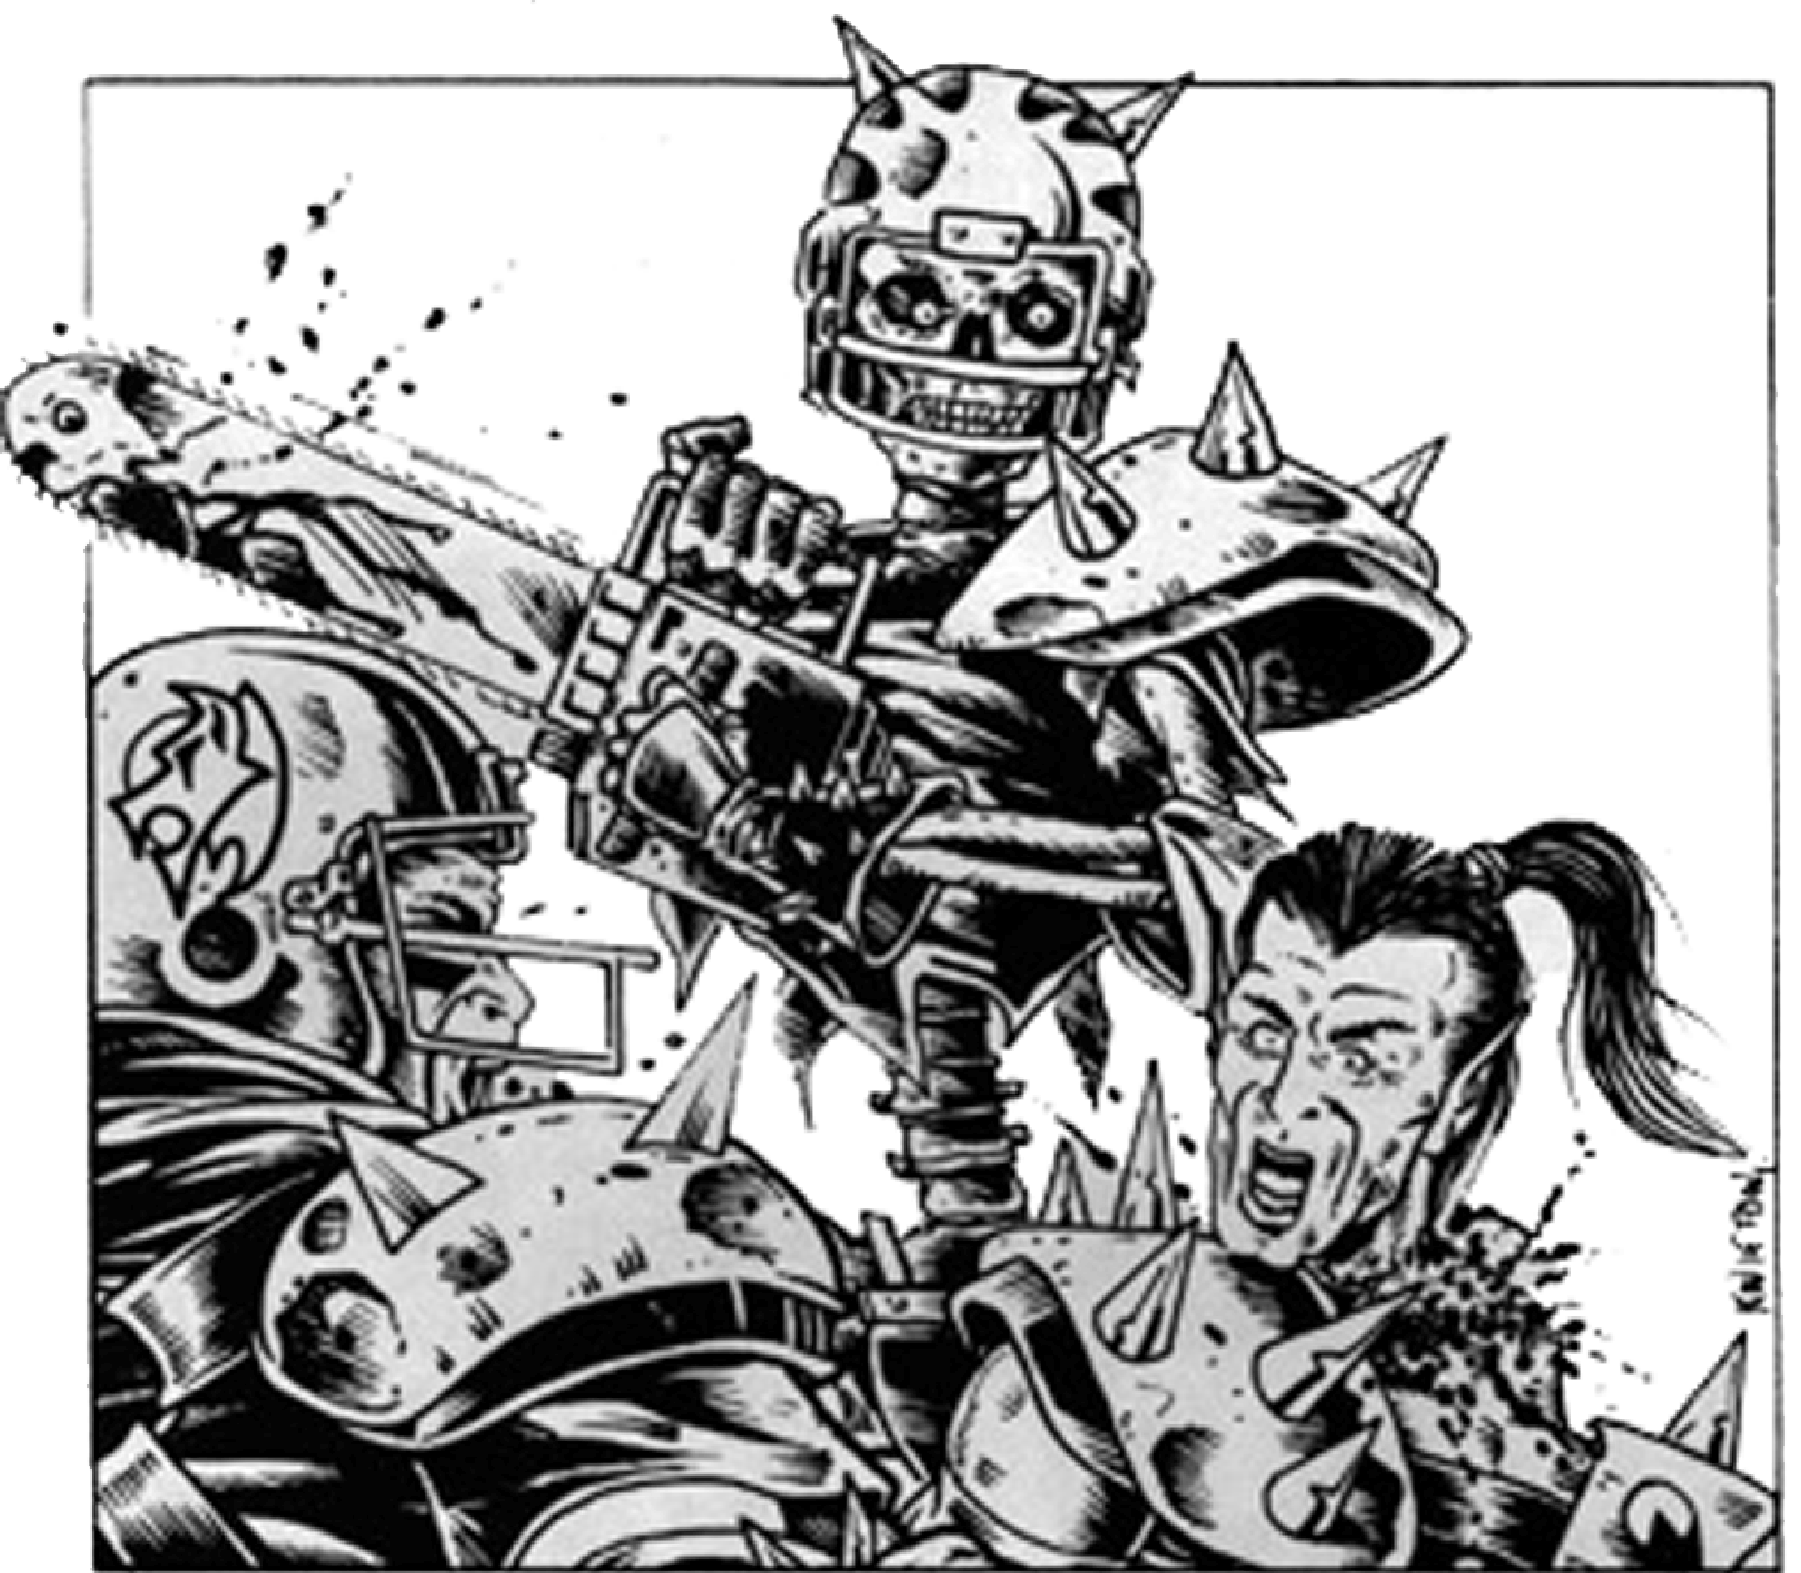

QUESTIONS? Email us at bothdownpodcast@gmail.com for Answers!

NUFFLEWEEN
KICK-OFF TABLE
2 | “The Spot-Light” – Bobby “BRAINS” Heenan and “Mean Green” Okerlund record a spot with each team before kickoff. Each team randomly chooses a player to do the spot. That player gains notoriety and the Foul Appearance skill FOR THE REST OF THE TOURNAMENT. This skill cannot be lost. Please mark the player.
3 | “Grotesque Living Onslaught of Wrestlers!”–The Frightening Boolah attacks WendiedRIPter and the fight rumbles onto the field holding up the game! Move the turn marker up one even if it ends the game.
4 | “Ghouls Just Wanna Have Fun!” – Captain Ghoul Albano brings out special guest Sin-Die Lauper and she sings her signature tune. Unfortunately this causes an army of ghouls to come streaming onto the pitch. In the confusion of clearing the crowd, one player from each team is placed in reserves. Choose for your own team.
5 | “Probability Schmobability”–The Undead Sheik and NikodieSkinoff are looking for trouble! Roll a D6 and add Fame. The lowest result (Or both if tied) will have a probability wizard in their employ knocked out. Lose a reroll. The probability wizard will return at the end of the half/game.
6 | “The Heels Have It!”–MrFearji and Dig Grave Studd grab the ball before kickoff and switch it with a Spiked Ball! On any failed Pick Up/Catch/Bouncing Ball(not Interception) roll Stab on the player who failed.
7 | “What’s that? A Full Moon?" - Reroll the weather as normal, however all results of 4-10 are replaced with: Full Moon – The Graveyard Dog sees the full moon and goes beserk! The referee is busy chasing him around the field. No fouls will be called for this drive/half. Reroll weather as normal at the end of this drive/half.
8 | “The Good Guys Try To Help!”–Grimmy “Superfly” Spooka and Tito Satan-a lay out the mats The ball will scatter D3 movement to the D8 direction whenever it hits the ground. Ends at the end of drive.
9 | “The Crowd Loves It!” - Each coach rolls 2 D6, add Fame. If the result is 10 or over, you get a reroll.
10 | “HOT ROT!” – Rowdy “Rotty” Piper himself has decided to take the pitch! Rotty jumps over the line and attacks one player on the receiving team. It will be a one die block with no assists. Then he runs off.
11 | “Nuffleween Double Team” – Having had enough of Hot Rot, Hulk Haunted and Andread the Giant double team and slam him to the ground causing a massive shake! Roll a D3 for each player on the pitch. On a 1 – They fall down and are stunned. On a 2 – They fall down and are prone. On a 3 – They remain standing.
12 | “Don’t Go Messin’ With A Country Boy!” – Hellbilly Jim’s theme music gets played across the PA system. This drives the crowd wild with excitement! The stadium shakes and a portal opens in the sky. Nuffle himself reaches down and gives a thumbs up. Each team gets to add one Pro skill to any player for free FOR THE REST OF THE TOURNAMENT. This skill cannot be lost.Please mark the player.

