Warpstone Tour: Orclahoma Edition

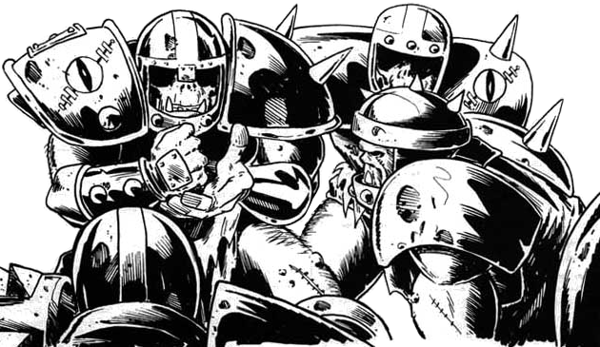

TOURNAMENT RULES PACK 1.0

July 26th, 2014 at Wizards Asylum
749 South Jenkins Avenue. Norman, OK 73069

Warpstone Tour: Orclahoma Edition

Cost

REGULAR Pre-register by July 21st, 2014
- $10 - Warpstone Tour: Orclahoma Bowl

AT THE DOOR
- $15 - At the door the day of the event

All Events can be signed up and paid for at BothDown.com

Pre-Registration Bonus
If you pre-register by July 21st, 2014 you get 2 additional Limited Edition Orclahoma Bowl D6’s and discounted tournament entry fee.

Pre-Registered Players should turn in Rosters by email for Approval by July 21st, 2014 or before.

Tournament Schedule
9:30 – Registration Starts
9:45 – Registration Ends
10:00 – Round 1 (Random)
12:15 – 1:15 – Lunch
1:15 – Round 2 (Swiss)
3:30 – Break
3:45 – Round 3 (Swiss)
6:00 – Break
6:15 – Results/Awards

What you should bring
- Your Blood Bowl Team* (See page 3)
- Four Copies (one for each round) of team roster
- Blood Bowl Field/Dugouts/Templates (if you have them)
- GW or NAF Block Dice & D8 (if you have them)
- Living Rulebook 6: http://zlurpcast.com/JP/LRB6.pdf

Things we will provide
- Pen
- Nametag
- Match Sheet
- Custom Dice
- Awards

This event is designed and encouraged for new Blood Bowl players. While made with them in mind, it is built and recommended for all levels of Blood Bowlers to come out and just have some good ole fun on the pitch.

Warpstone Tour Team Building and Special Rules

Team Building Rules
You are given 1,000,000 gold pieces to build your team using CRP team lists or the three additional Team Lists. You may purchase players, rerolls, fan factor, coaches, apothecary and cheerleaders as normal. This is a "come as you are" event, no additional skills will be given to the players while building the team.

Wizards, Journeymen, Star Players, Special Play cards, and Mercenaries are NOT ALLOWED. With that said, you may purchase any other inducements as part of your team built.

CRP Star Players
Note: For this event no Star Players are allowed!

Warpstone Special Mutation Rules
Before each round, a nasty Warpstone Troll will bring your team some shiny Warpstone to randomly rub on your players to bless them with a Mutation.

The players on the Top Table will each roll on the Mutation Table (see below) and each team will receive both of those Mutations. Once the mutations are decided. Each coach will randomly roll to see which players or player is blessed with one or more mutations.

1 | Big Hand | 6 | Horns
2 | Claw | 7 | Prehensile Tail
3 | Disturbing Presence | 8 | Tentacles
4 | Extra Arms | 9 | Two Heads
5 | Foul Appearance | 10 | Very Long Legs

This will happen before each round so multiple mutations could end up going to the same player over the course of the day. In the rare event a player gets randomly selected for a mutation he has already received then that coach may randomly pick a new player for that mutation.

After mutations have been assigned please note the new mutation skill on your roster for that player. We will also be handing out colored bands for each mutation received to help note who has what on the field of play.

NAF Tournament Info
This is a NAF approved US Major tournament. If you wish to receive limited edition colored Block Dice and have your tournament progress tracked, there will be an NAF Official onsite accepting registration for the cost of $10/year. More information can be found at TheNAF.net

Illegal Procedure
In the spirit of good sportsmanship, Illegal Procedures will not be called

Timing
The game round time limit WILL be strictly enforced. You will receive ‘Time Remaining’ updates from the Tournament Organizer to help you stay on pace.

The 4 Minute turn rule will not be used unless the Tournament organizer feels your game is in danger of not completing in the two hour timelimit. He may insist on a timer being used and enforcing the 4 minute turn rule.

Dice
You are required to share dice with your opponent. Only GW or NAF Block Dice may be used and only the Warpstone Tour: Orclahoma Bowl D6’s received at registration may be used. You and your opponent should decide whose set of dice will be used.

Scoring
After each round you will fill out both the game sheet and the etiquette sheet based on the game just completed.
- A WIN is worth 60pts
- A DRAW is worth 30pts
- A LOSS is worth 10pts
- If you lost by 1 Touchdown, you earn +2 bonus pts
- If you caused 1 more CAS from Blocking than opp you earn +2 bonus pts
- If you caused 2 or more CAS from Blocking than opp you earn +5 bonus pts
- If you clear the pitch you earn +5 bonus pts
- If you won by 2 Touchdowns you earn +2 bonus pts
- If you won by 3 or more Touchdowns you earn +5 bonus pts
- If you finished the game by using all turns +3 bonus pts

There is a no championship game the standings will solely be determined by total points.

Overtime
There will be no overtime played. If your game ends in a draw, it’s a draw.

Tiebreakers
The Scoring system has been setup to hopefully get the most accurate representation of how everyone has per-formed. If, by chance there is a tie in Tournament points, the ties will be broken in this order:
- Winning Percentage
- Head to Head record
- Net TDs plus Net CAS
- Total TDs plus Total CAS

If it is still a tie at that point, the tournament organizer will use his best judgment in finding a way to break the tie.

Your Blood Bowl Team: Painting
Since this is a beginner type tournament we understand some people might not have a team painted yet, so we expect the models to be numbered correctly and for the positions to be clearly marked in the very least. Come out and have fun.

Sportsmanship
We are here for the fun of the game. Sportsmanship is not encouraged from the coaches it is required!

Fouling 16 turns in a row and running up the score is not poor sportsmanship, but gloating and ridiculing your opponent while doing so is.

Tournament Organizer will strictly enforce the “Don’t be a Douche” policy. Basically, it consists of not performing any acts of Douchebaggery.

Awards
The following awards will be given out after the last round:
  - Warpstone Tour Champion - Most points scored
  - Warpstone Tour 2nd Place – 2nd most points scored
  - Warpstone Tour 3rd Place- 3rd most points scored
  - Best Sportsman - Best Sportsman as decided by player vote. Tournament Organizer will have final say and break any ties.
  - Additional Awards like Best Defense, Best Offense, Most Brutal could be added to the prize pool depending on tournament attendance.

Spread The Wealth
A coach may only win one award. If they are in line to win more than one award, they will be asked which one they would prefer and the next coach in line will be given the other award.

QUESTIONS? Email us at OrclahomaBowl@gmail.com for Answers!

Rules Packet Updated 06-19-2014

